THE COUNCIL OF THE CITY OF NEW YORK
RESOLUTION NO. 1038

Resolution approving with modifications the decision of the City Planning Commission on Application No. N 240224 ZRQ, for an amendment of the text of the Zoning Resolution (L.U. No. 338).

By Council Members Salamanca and Riley

WHEREAS, CG Stone Realty, LLC, filed an application pursuant to Section 201 of the New York City Charter, for an amendment of the text of the Zoning Resolution of the City of New York, modifying APPENDIX F for the purpose of establishing a Mandatory Inclusionary Housing area, which in conjunction with the related action would facilitate the enlargement of a single-story commercial building into a five-story mixed-use building with 32 dwelling units, of which eight would be permanently income-restricted, with ground-floor retail located at 42-11 30th Avenue in Astoria, Queens, Community District 1 (ULURP No. N 240224 ZRQ), (the “Application”);

WHEREAS, the City Planning Commission filed with the Council on July 7, 2025, its decision dated June 18, 2025 (the "Decision") on the Application;

WHEREAS, the Application is related to application C 240223 ZMQ (L.U. No. 337), a zoning map amendment to change a R5/C1-2 zoning district to an R6A/C2-4 zoning district;

WHEREAS, the Decision is subject to review and action by the Council pursuant to Section 197-d of the City Charter;

WHEREAS, upon due notice, the Council held a public hearing on the Decision and Application on July 8, 2025;

WHEREAS, the Council has considered the land use implications and other policy issues relating to the Decision and Application; and

WHEREAS, the Council has considered the relevant environmental issues, including the Revised Environmental Assessment Statement (EAS) and the Revised Negative Declaration issued June 16th, 2025 (CEQR No. 24DCP070Q), which supersedes the Negative Declaration issued on February 14th, 2025, and which includes an (E) designation related to hazardous materials and air quality (E-804) (the “Revised Negative Declaration”).
RESOLVED:

The Council finds that the action described herein will have no significant impact on the environment as set forth in the (E) Designation (E-804) and Revised Negative Declaration.

Pursuant to Sections 197-d and 200 of the City Charter and on the basis of the Decision and Application, and based on the environmental determination and consideration described in the report, N 240224 ZRQ, incorporated by reference herein, and the record before the Council, the Council approves the Decision of the City Planning Commission, with the following modifications.

Matter underlined is new, to be added;
Matter struck out is to be deleted;
Matter double-underlined is new, added by the City Council;
Matter double struck out is old, deleted by the City Council;
Matter within # # is defined in Section 12-10;
* * * indicates where unchanged text appears in the Zoning Resolution.

* * *
APPENDIX F
Mandatory Inclusionary Housing Areas and former Inclusionary Housing Designated Areas
* * *
QUEENS
* * *
Queens Community District 1
* * *
Map 9 – [date of adoption]
[EXISTING MAP]
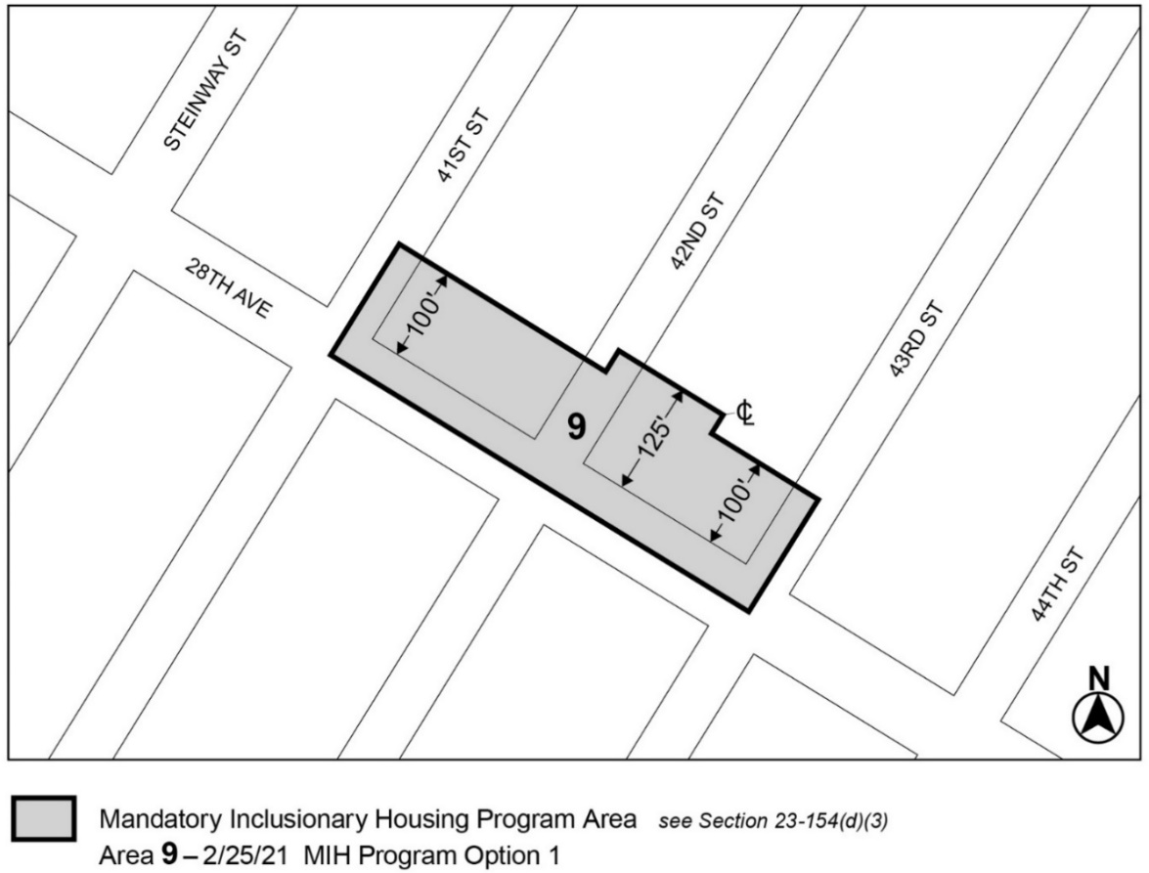

* * *
Map 11 – (10/5/23)
[EXISTING MAP]
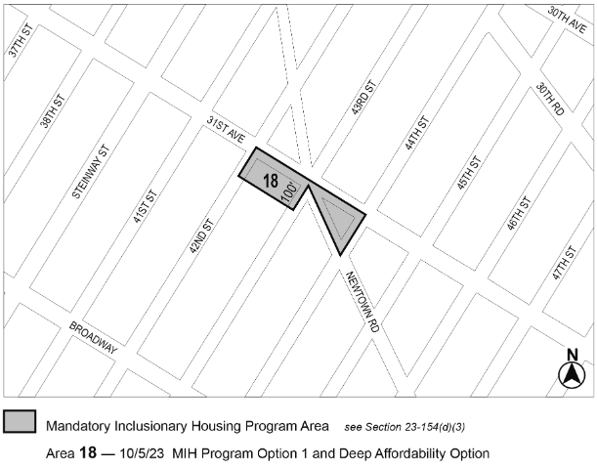

[PROPOSED MAP]
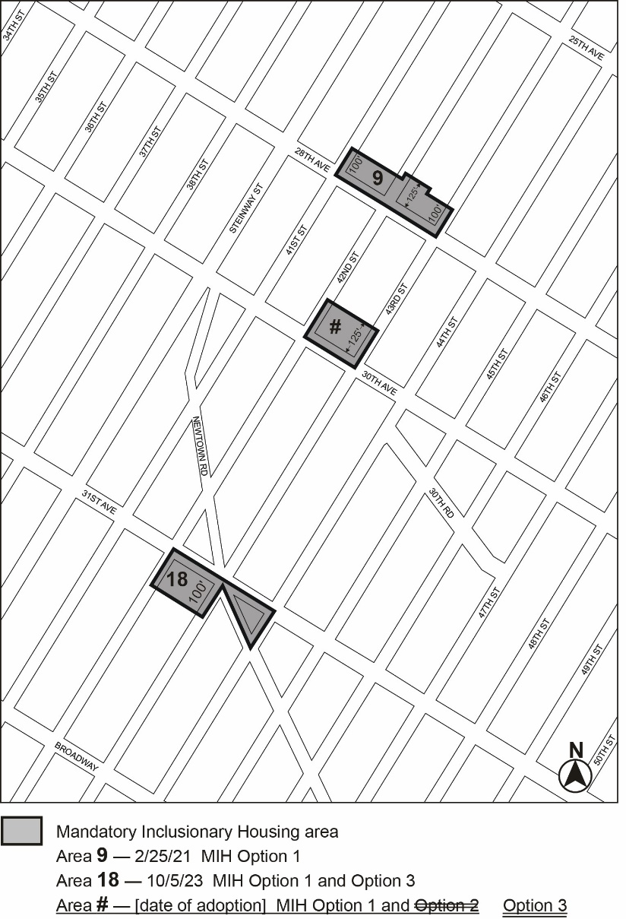
Portion of Community District 1, Queens
* * *
Adopted.

Office of the City Clerk,}
The City of New York,} ss.:

I hereby certify that the foregoing is a true copy of a Resolution passed by The Council of The City of New York on _________, 2025, on file in this office.

.....................................................
City Clerk, Clerk of The Council

