THE COUNCIL OF THE CITY OF NEW YORK
RESOLUTION NO. 348

Resolution approving the decision of the City Planning Commission on Application No. N 220008 ZRX, for an amendment of the text of the Zoning Resolution (Preconsidered L.U. No. 103).

By Council Members Salamanca and Riley

WHEREAS, Throggs Neck Associates, LLC, filed an application pursuant to Section 201 of the New York City Charter, for an amendment of the text of the Zoning Resolution of the City of New York, modifying APPENDIX F for the purpose of establishing a Mandatory Inclusionary Housing Area, which in conjunction with the related action would facilitate the development of four mixed-use buildings, in the Schuylerville neighborhood of the Bronx, Community District 10 (ULURP No. N 220008 ZRX) (the “Application”);

WHEREAS, the City Planning Commission filed with the Council on August 26, 2022, its decision dated August 24, 2022 (the “Decision”), on the Application;

WHEREAS, the Application is related to application C 220007 ZMX (Preconsidered L.U. No. 102), a zoning map amendment to change R4A/C1-2, R4A, R4-1/C2-4 and R4-1 zoning districts to R6A/C2-4, R6A and R5B/C2-4 zoning districts;

WHEREAS, the Decision is subject to review and action by the Council pursuant to Section 197-d of the City Charter;

WHEREAS, upon due notice, the Council held a public hearing on the Decision and Application on September 7, 2022;

WHEREAS, the Council has considered the land use implications and other policy issues relating to the Decision and Application; and

WHEREAS, the Council has considered the relevant environmental issues, including the Revised Negative Declaration issued August 22nd, 2022, which supersedes the Negative Declaration issued March 28th, 2022, and Revised Environmental Assessment Statement issued August 19th, 2022 (CEQR No. 22DCP015X) which includes information related to water and sewer infrastructure analysis and concludes that the additional information would not alter the conclusions of the EAS issued March 25, 2022; and which includes an (E) designation to avoid the potential for significant adverse impacts related to hazardous materials, air quality, and noise (E-669) (the “Revised Negative Declaration”).

RESOLVED:

The Council finds that the action described herein will have no significant impact on the environment as set forth in the (E) Designation (E-669) and Revised Negative Declaration.

Pursuant to Sections 197-d and 200 of the City Charter and on the basis of the Decision and Application, and based on the environmental determination and consideration described in the report, N 220008 ZRX, incorporated by reference herein, and the record before the Council, the Council approves the Decision of the City Planning Commission.

Matter underlined is new, to be added;
Matter struck out is to be deleted;
Matter within # # is defined in Section 12-10;
* * * indicates where unchanged text appears in the Zoning Resolution.

APPENDIX F
Inclusionary Housing Designated Areas and Mandatory Inclusionary Housing Areas

* * *
BRONX

Bronx Community District 10

* * *
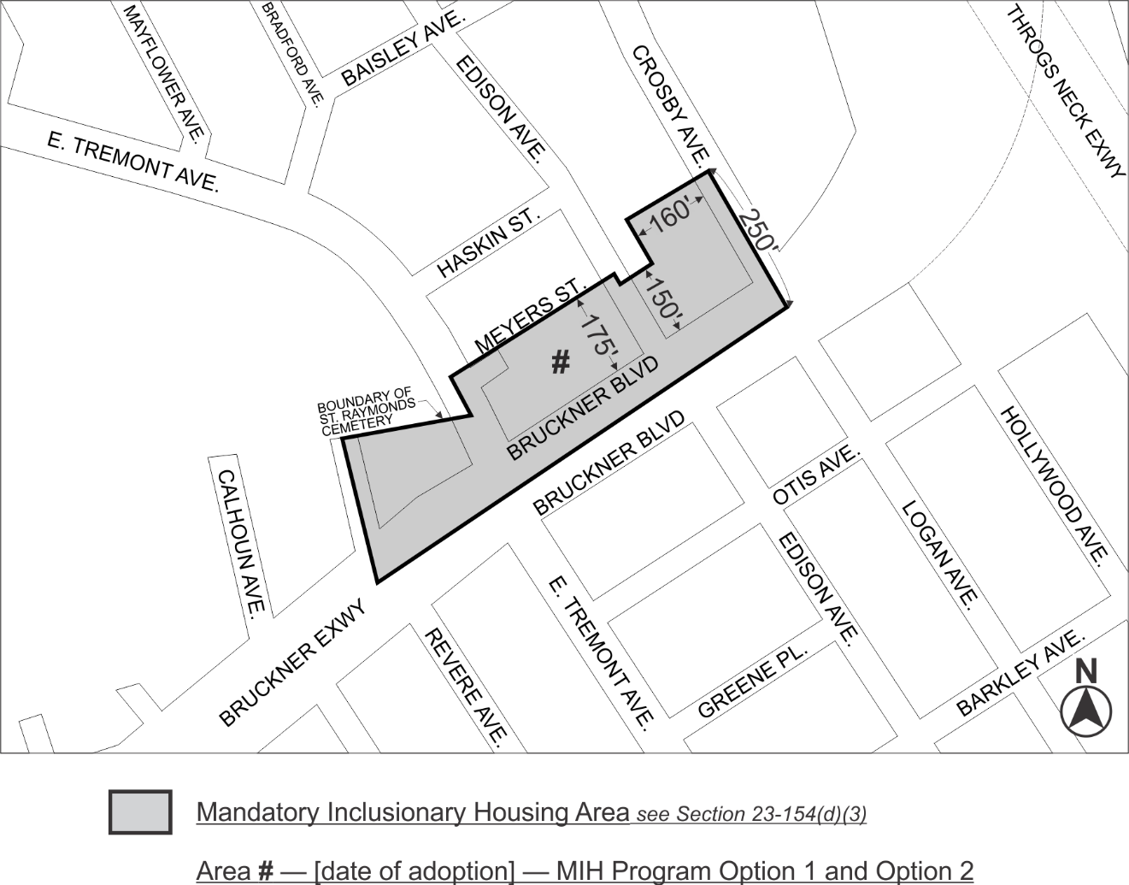

Portion of Community District 10, Bronx

* * *

Adopted.

Office of the City Clerk, }
The City of New York, } ss.:

I hereby certify that the foregoing is a true copy of a Resolution passed by The Council of The City of New York on __________, 2022, on file in this office.

.....................................................
City Clerk, Clerk of The Council

