THE COUNCIL OF THE CITY OF NEW YORK
RESOLUTION NO. 582

Resolution approving the decision of the City Planning Commission on Application No. N 260106 ZRK for an amendment of the text of the Zoning Resolution (L.U. No. 68).

By Council Members Riley and Louis
WHEREAS, GoQuay LLC and the New York State Metropolitan Transportation Authority, filed an application pursuant to Section 201 of the New York City Charter, for an amendment of the Zoning Resolution of the City of New York (“ZR”), amending provisions of Article VI, Chapter 2 (Special Regulations Applying in the Waterfront Area) and Article VII, Chapter 4 (Special Permits by the City Planning Commission) and amending Appendix F (Mandatory Inclusionary Housing Areas and former Inclusionary Housing Designated Areas) for the purpose of establishing a Mandatory Inclusionary Housing area, which in conjunction with the related applications would facilitate a proposed mixed-use large-scale general development containing residential, commercial and community facility uses in the Borough of Brooklyn, Community District 1 (ULURP No. N 260106 ZRK) (the "Application");
WHEREAS, the City Planning Commission filed with the Council on May 13, 2026, its decision dated May 13, 2026 (the "Decision") on the Application;
WHEREAS, the Application is related to applications C 260105 ZMK (L.U. No. 67), a zoning map amendment to rezone an M3-1 to an R8 and R6 zoning district and rezone R6, R6/C2-4 districts to R8/C2-4 zoning district; C 260107 ZSK (L.U. No. 69), a zoning special permit pursuant to ZR Section 74-743 to modify height and setback requirements, maximum tower widths and sizes, and minimum waterfront yard requirements; and C 250326 MMK (L.U. No. 71), a City Map change to remove the entirety of Block 2590, Lot 25 and the northern half of Former Quay Street as designated park in the City Map (collectively, the “Related Actions”);
WHEREAS, the Decision is subject to review and action by the Council pursuant to Section 197-d of the City Charter;
WHEREAS, upon due notice, the Council held a public hearing on the Decision and Application on May 27, 2026;
WHEREAS, the Related Actions originally included a decision of the City Planning Commission for application C 260109 ZSK (L.U. No. 70), seeking a special permit to modify loading requirements, which was subsequently withdrawn by the applicants GoQuay LLC and the New York State Metropolitan Transportation Authority, pursuant to a written statement dated June 25, 2026 and submitted to the Council on June 25, 2026;
WHEREAS, the Council has considered the land use implications and other policy issues relating to the Decision and Application; and
WHEREAS, the Council has considered the relevant environmental issues, including the Positive Declaration issued on March 21, 2025 (CEQR No, 25DCP068K) and the Final Environmental Impact Statement (the “FEIS”), for which a Notice of Completion was issued on April 30, 2026. The FEIS determined that approval of the Related Actions would result in significant adverse impacts related to transportation (traffic, pedestrians) and construction (traffic, pedestrians, noise) and identified proposed mitigation measures under the Related Actions in Chapter 19, “Mitigation,” of the FEIS. Significant adverse impacts related to hazardous materials and air quality would be avoided by the placement of an (E) designation (E-870) on the NYCTA Relocation Site, while the existing (E) designation (E-138) for hazardous materials would continue to govern the Development Site (collectively, the “E-Designations”). The significant adverse impacts that would not be fully mitigated are summarized in Chapter 21, “Unavoidable Adverse Impacts,” of the FEIS. The applicant will enter into a restrictive declaration at the time of approval of the Related Actions and prior to issuance of any permit to ensure the implementation of Project Components Related to the Environment (“PCREs”) incorporated into the FEIS (the “Restrictive Declaration”). A Technical Memorandum was issued on _______, 2026 (the “Technical Memorandum”) to consider the Council’s modifications to the Related Actions, and concluded that the Related Actions, as modified, would not result in any significant adverse environmental impacts that were not already identified in the FEIS (the FEIS, the E-designations, the Restrictive Declaration and the Technical Memorandum are collectively referred to as the “Environmental Documentation”).
RESOLVED:
Having considered the Environmental Documentation with respect to the Decision and Application, the Council finds that:
- The environmental impacts disclosed in the FEIS were evaluated in relation to the social, economic, and other considerations associated with the Related Actions that are set forth in the Decision;
- Consistent with social, economic and other essential considerations from among the reasonable alternatives available, the Related Actions are those which avoid or minimize adverse environmental impacts to the maximum extent practicable; and
- The adverse environmental impacts identified in the FEIS will be minimized or avoided to the maximum extent practicable by incorporating as conditions to the approval, pursuant to the Restrictive Declaration dated May 13, 2026, and attached as Exhibit A to the Decision for C 260107 ZSK and C 260109 ZSK, those project components related to the environment and mitigation measures that were identified as practicable.
The Decision, together with the Environmental Documentation, constitutes the written statement of findings, and of social, economic, and other factors and standards that form the basis of this determination, pursuant to Section 617.11(d) of the SEQRA regulations.
Pursuant to Section 197-d of the New York City Charter and based on the Decision and Application, the environmental determination and consideration described in the report, N 260106 ZRK, incorporated by reference herein, and the record before the Council, the Council approves the Decision, as follows:
Matter underlined is new, to be added;
Matter struck out is to be deleted;
Matter within # # is defined in Section 12-10;
* * * indicates where unchanged text appears in the Zoning Resolution.

* * *
ARTICLE VI
SPECIAL REGULATIONS APPLICABLE TO CERTAIN AREAS

Chapter 2
Special Regulations Applying in the Waterfront Area

* * *
62-30
SPECIAL BULK REGULATIONS

* * *
62-36
Special Bulk Regulations in Certain Areas Within Community District 1, Brooklyn

On #waterfront blocks# in Waterfront Access Plan BK-1 in Community District 1, Borough of Brooklyn, the special #bulk# regulations of this Chapter are further modified as set forth in this Section, inclusive.

62-361
Special floor area regulations
[REVISING FAR FOR MIH AREAS]
(a) R6 R7 R8
In the districts indicated, the maximum #residential# #floor area ratio# shall be as follows: set forth in the following table. Separate maximum #residential# #floor area ratios# are set forth for #zoning lots# containing standard #residences# and #zoning lots# containing #qualifying affordable housing# or #qualifying senior housing#.
(1) For #zoning lots# located in #Mandatory Inclusionary Housing areas#, the maximum #residential# #floor area ratio# shall be as set forth in Section 23-22 (Floor Area Regulations for R6 Through R12 Districts); or
(2) For #zoning lots# located outside of #Mandatory Inclusionary Housing areas#, the maximum #residential# #floor area ratio# shall be as set forth in the following table. Separate maximum #residential# #floor area ratios# are set forth for #zoning lots# containing standard #residences# and #zoning lots# containing #UAP developments# or #qualifying senior housing#.
MAXIMUM FLOOR AREA RATIO FOR R6-R8 DISTRICTS
District | Standard #residences# | #Qualifying affordable housing# #UAP developments# or #qualifying senior housing#
R6 | 2.54 | 3.05
R7-3 | 4.17 | 5.00
R8 | 5.42 | 6.50

(b) #Buildings# used for #accessory# off-street parking spaces
* * *
62-363
Special height and setback regulations
[REVISING HEIGHTS FOR MIH DEVELOPMENTS IN R8 DISTRICTS]
Within Waterfront Access Plan BK-1, the provisions of Section 62-30 (SPECIAL BULK REGULATIONS) are modified, as follows:
(a) The maximum base heights of paragraph (a) of Section 62-343 (Height and setback regulations in other medium- and high-density districts) shall be modified in R6 Districts to permit a maximum base height of 65 feet or six #stories#, whichever is less.
(b) The maximum #building# heights of Section 62-343 shall not apply. In lieu thereof, the provisions of this paragraph, (b), shall apply:
(1) The maximum #building# height in an R6 District shall be 65 feet or six #stories#, whichever is less, within 100 feet of Commercial Street, West Street, Dupont Street, Franklin Street and Kent Avenue. However, for #buildings or other structures# with #qualifying affordable housing# or #qualifying senior housing# the maximum #building# height shall be 75 feet.
Beyond 100 feet of such #streets# and any other portions of an R6 District, the maximum #building# height shall be 110 feet. In R8 Districts, the maximum #building# height shall be 190 feet, except that for #zoning lots# #developed#
with multiple #buildings# or portions of #buildings# that exceed a height of 180 feet, not more than half of such #buildings# or portions of #buildings# may exceed a height of 190 feet, to a maximum #building# height of 290 feet. Such maximum #building# heights of 110 feet, 190 feet and 290 feet may be exceeded by a penthouse portion of a #building#, pursuant to the provisions of paragraph (b)(3) of this Section.
(2) For #developments# that provide #zoning lots# containing #qualifying affordable housing# or #qualifying senior housing#, the height limits of an R8 District set forth in paragraph (b)(1) of this Section may be exceeded, provided that:
- outside of #Mandatory Inclusionary Housing areas#, the height limits of an R8 District set forth in paragraph (b)(1) of this Section may be exceeded, provided that the maximum #building# height shall be 260 feet,. except that However, for #zoning lots# #developed# with multiple #buildings# or portions of #buildings# that exceed a height of 200 feet, not more than half of such #buildings# or portions of #buildings# may exceed a height of 260 feet to a maximum #building# height of 360 feet. Such maximum #building# heights of 260 feet and 360 feet may be exceeded by a penthouse portion of a #building#, pursuant to the provisions of paragraph (b)(3) of this Section. ; or
- in #Mandatory Inclusionary Housing areas#, the maximum #building# height shall be 500 feet. However, for #zoning lots# #developed# with multiple #buildings# or portions of #buildings# that exceed a height of 440 feet, not more than half of such #buildings# or portions of #buildings# may exceed a height of 500 feet to a maximum #building# height of 600 feet.
* * *
62-90
WATERFRONT ACCESS PLANS
* * *
62-93
Borough of Brooklyn
* * *
62-931
Waterfront Access Plan BK-1: Greenpoint-Williamsburg
[REMOVING PARCEL 19 FROM PARKS DESIGNATION]
Maps BK-1a through BK-1c in paragraph (f) of this Section show the boundaries of the area comprising the Greenpoint-Williamsburg Waterfront Access Plan and the location of certain features mandated or permitted by the Plan. The plan area has been divided into parcels consisting of tax blocks and lots and other lands as established on May 11, 2005, as follows:
* * *
(d) Special public access provisions by parcel
* * *
(11) Parcel 15
An #upland connection# shall be provided within the prolongation of the #street lines# of West Street, connecting Quay Street to Parcel 20.
(12) Parcels 19, 20, 21 and 22
Parcels 19, 20, 21 and 22 shall be designated as public #parks# as of May 11, 2005.
(13) Parcel 25
* * *
ARTICLE VII
ADMINISTRATION
Chapter 4
Special Permits by the City Planning Commissions
74-70
ADDITIONAL PERMITS
* * *
74-74
Large-scale General Development
* * *
74-745
Modifications of parking and loading regulations
[REVISING APPLICABILITY OF LOADING BERTH WAIVER]
For a #large-scale general development# the City Planning Commission may permit:
* * *
(b) Waiver or reduction of loading berth requirements
For #zoning lots# in a #large-scale general development#, located either within a #Special Mixed Use District# in Community District 2 in the Borough of The Bronx, or within a waterfront area pursuant to paragraph (b) of Section 62-132, in Community District 1 in the Borough of Brooklyn, where such #zoning lots# in the waterfront area contain one or more retail or service #uses# listed in Use Group VI and where no single such establishment in the waterfront area exceeds 8,500 square feet in #floor area#, or for #zoning lots# located in #large-scale general developments# within #Special Mixed Use District# 24 in Community District 1 in the Borough of Queens, the Commission may waive or reduce the number of required loading berths, provided that:
(1) curbside deliveries will not create or contribute to serious traffic congestion or unduly inhibit vehicular or pedestrian movement and will not interfere with the efficient functioning of nearby #uses#;
(2) an efficient goods receiving system will be implemented within the #commercial# establishment to expedite the movement of goods from the curb to areas within the establishment;
(3) such modification allows for a better relationship between the #street walls# of the #building# containing such establishment and the adjacent sidewalk and surrounding area; and
(4) such modification will not impair or adversely affect the development of the surrounding area.
For #zoning lots# in a #large-scale general development# located in a geography set forth in this Section, the Commission may waive or reduce the number of required loading berths, provided that the findings in paragraph (b)(2) are met.
(1) The following geographies are eligible for the loading berth modifications of this paragraph:
(i) within #Special Mixed Use District# 17 in Community District 2 in the Borough of The Bronx;
(ii) within #Special Mixed Use District# 24 in Community District 1 in the Borough of Queens;
(iii) within Waterfront Access Plan BK-1 in Community District 1 in the Borough of Brooklyn; or
(iv) #zoning lots# in waterfront areas subject to the provisions of paragraph (b) of Section 62-132 (Applicability of Article VII, Chapters 4, 5, 8 and 9), in Community District 1 in the Borough of Brooklyn, outside of Waterfront Access Plan BK-1, where such #zoning lots# in the waterfront area contain one or more retail or service #uses# listed in Use Group VI and where no single such establishment in the waterfront area exceeds 8,500 square feet in #floor area#.
(2) In order to grant the special permit, the Commission shall find that:
(i) curbside deliveries will not create or contribute to serious traffic congestion or unduly inhibit vehicular or pedestrian movement and will not interfere with the efficient functioning of nearby #uses#;
(ii) an efficient goods receiving system will be implemented within the #commercial# establishment to expedite the movement of goods from the curb to areas within the establishment;
(iii) such modification allows for a better relationship between the #street walls# of the #building# containing such establishment and the adjacent sidewalk and surrounding area; and
(iv) such modification will not impair or adversely affect the development of the surrounding area.
(c) Reduction of parking requirements
* * *
APPENDIX F
Mandatory Inclusionary Housing Areas and former Inclusionary Housing Designated Areas
BROOKLYN
Brooklyn Community District 1
Map 1 - [date of adoption]
[EXISTING MAP]
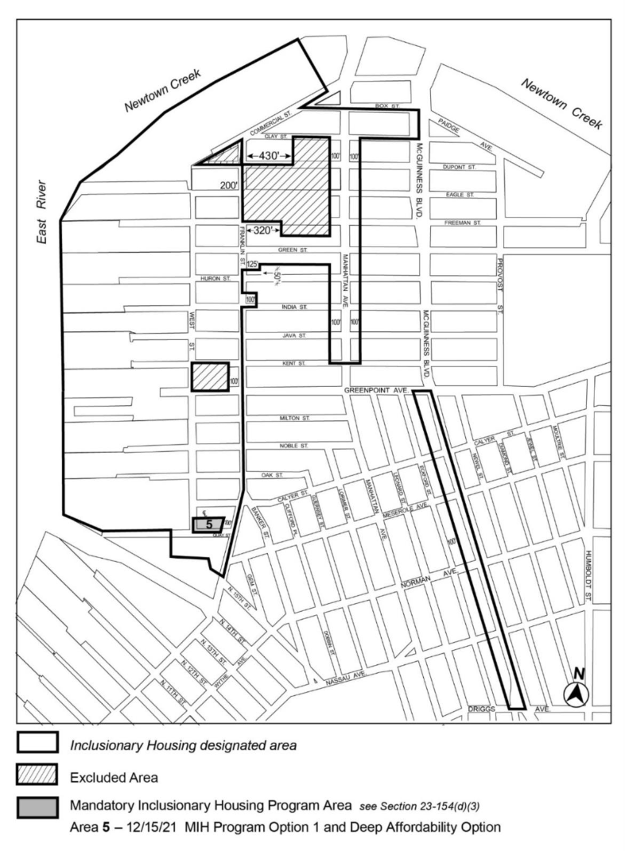

[PROPOSED MAP]
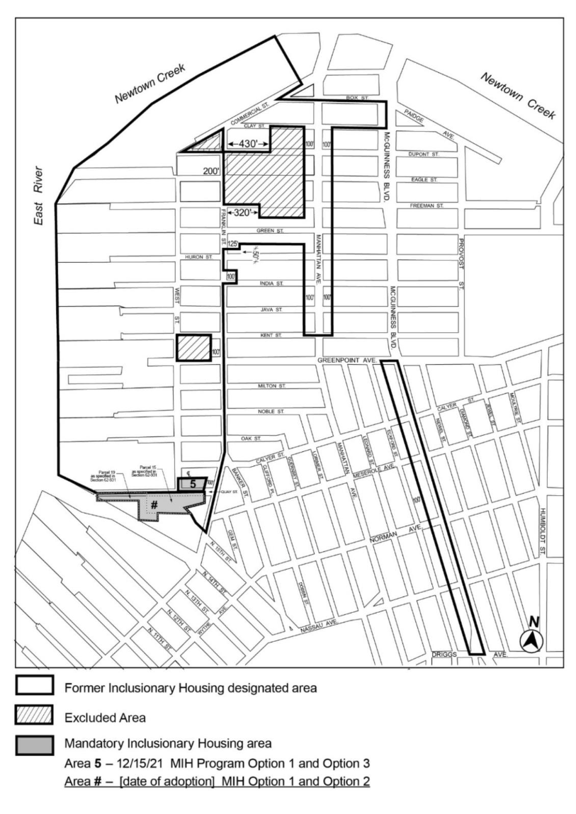
Portion of Community District 1, Brooklyn
* * *
Adopted.

Office of the City Clerk, }
The City of New York, } ss.:

I hereby certify that the foregoing is a true copy of a Resolution passed by The Council of The City of New York on ______________, on file in this office.

.....................................................
City Clerk, Clerk of The Council

