THE COUNCIL OF THE CITY OF NEW YORK
RESOLUTION NO. 605

Resolution approving with modifications the decision of the City Planning Commission on Application No. N 180086 ZRQ (L.U. No. 245), for an amendment of the Zoning Resolution of the City of New York, modifying Appendix F for the purpose of establishing a Mandatory Inclusionary Housing area, Community District 1, Borough of Queens.

By Council Members Salamanca and Moya

WHEREAS, the City Planning Commission filed with the Council on September 28, 2018 its decision dated September 26, 2018 (the "Decision"), pursuant to Section 201 of the New York City Charter, regarding an application submitted by Variety Boys and Girls Club of Queens, for an amendment of the text of the Zoning Resolution of the City of New York, modifying Appendix F for the purpose of establishing a Mandatory Inclusionary Housing area, which in conjunction with the related action would facilitate the development of a building with community facility, commercial and residential uses at 21-12 30th Road in the Astoria neighborhood of Queens, Community District 1, (Application No. N 180086 ZRQ), Community District 1, Borough of Queens (the "Application");

WHEREAS, the Application is related to application C 180085 ZMQ (Pre. L.U. No. 244), a zoning map amendment to change an R7Aand an R6B zoning district to a R7X district;

WHEREAS, the Decision is subject to review and action by the Council pursuant to Section 197-d(b)(1) of the City Charter;
WHEREAS, upon due notice, the Council held a public hearing on the Decision and Application on October 3, 2018;

WHEREAS, the Council has considered the land use implications and other policy issues relating to the Decision and Application; and

WHEREAS, the Council has considered the relevant environmental issues, including the negative declaration issued May 7, 2018 (CEQR No. 18DCP121Q), which includes an (E) designation to avoid the potential for significant adverse impacts related to hazardous materials, air quality and noise, and would apply to the development site Block 550, Lots 7 and 10 (E-478), which supersedes the (E) designation for hazardous materials and air quality placed on Lot 7 as part of the Astoria Rezoning (E-245) (CEQR No. 10DCP019Q) (the “Negative Declaration”).

RESOLVED:

The Council finds that the action described herein will have no significant impact on the environment as set forth in the Negative Declaration.

Pursuant to Section 200 of the City Charter and on the basis of the Decision and Application, and based on the environmental determination and consideration described in the report, N 180086 ZRQ, incorporated by reference herein, the Council approves the Decision of the City Planning Commission with the following modifications:

Matter underlined is new, to be added;
Matter struck out is to be deleted;
Matter within # # is defined in Section 12-10;
Matter double struck out is old, deleted by the City Council;
Matter double-underlined is new, added by the City Council
* * * indicates where unchanged text appears in the Zoning Resolution.

* * *

APPENDIX F
Inclusionary Housing Designated Areas and Mandatory Inclusionary Housing Areas

* * *

QUEENS

* * *

Queens Community District 1

Map 4 - [date of adoption]

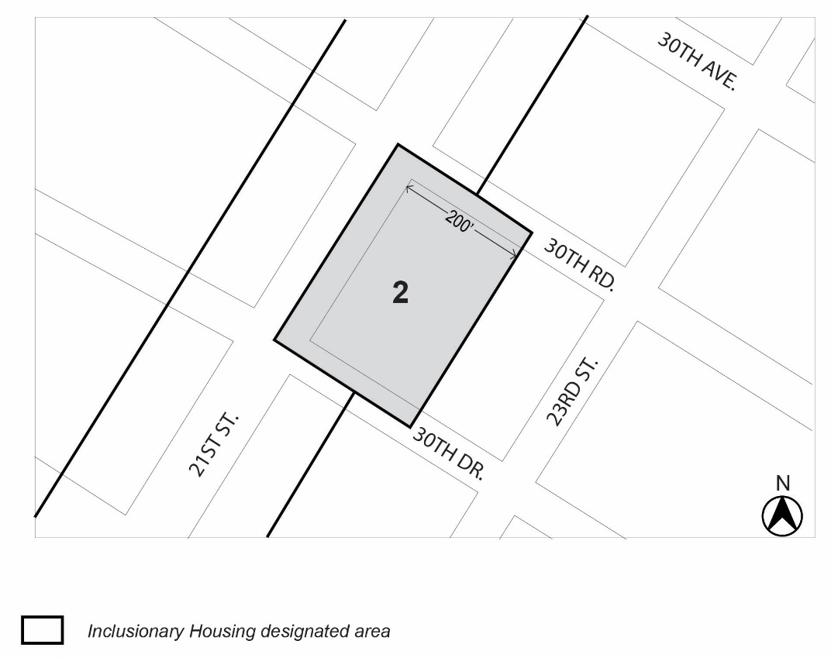

Mandatory Inclusionary Housing Program Area (see Section 23-154(d)(3))
Area 2 – [date of adoption] – MIH Program Option 1 and Option 2

Portion of Community District 1, Queens

* * *
Adopted.

Office of the City Clerk, }
The City of New York, } ss.:

I hereby certify that the foregoing is a true copy of a Resolution passed by The Council of The City of New York on October 31, 2018 on file in this office.

.....……......................................... City Clerk, Clerk of The Council

