Committee on Education
Malcom M. Butehorn, Senior Counsel
Jan Atwell, Senior Policy Analyst
Kalima Johnson, Policy Analyst
Kaitlyn O’Hagan, Senior Financial Analyst
Chelsea Baytemur, Financial Analyst

Committee on Civil and Human Rights
Balqees Mihirig, Senior Counsel
Leah Skrzypiec, Policy Analyst
Nevin Singh, Finance Analyst



THE COUNCIL OF THE CITY OF NEW YORK

BRIEFING PAPER OF THE HUMAN SERVICES AND

GOVERNMENTAL AFFAIRS DIVISION
Jeffrey Baker, Legislative Director
Andrea Vazquez, Deputy Director for Human Services
Rachel Cordero, Deputy Director for Governmental Affairs

COMMITTEE ON EDUCATION
Hon. Mark Treyger, Chair

COMMITTEE ON CIVIL AND HUMAN RIGHTS
Hon. Mathieu Eugene, Chair

May 1, 2019

Oversight: Segregation in New York City Schools

Introduction
On May 1, 2019, the Committee on Education, chaired by Council Member Mark Treyger, and the Committee on Civil and Human Rights, chaired by Council Member Mathieu Eugene, will hold a joint oversight hearing on “Segregation in New York City Schools.” This is the first hearing on diversity that the Committee on Education has held this session. During the prior Legislative Session, the Council held hearings on the issue of diversity in NYC schools in December 2014 and December 2017. Representatives from the Department of Education (DOE), the New York City Commission on Human Rights (CCHR), union leaders, advocates, educators, parents, and students have been invited to testify.
Background
Brown v. Board of Education was a 1954 U.S. Supreme Court case in which the Court held that segregation of students in public schools violates the Equal Protection Clause of the Fourteenth Amendment of the United States Constitution, because separate facilities are inherently unequal. This Supreme Court decision mandated the desegregation of public schools across the country and paved the way for integration efforts to begin in earnest. While New York City (NYC) is more racially diverse today than it was in 1954, its public schools are some of the most segregated in the country. Nationally, the “United States is resegregating, with the number of schools that are less than 40% white doubling between 1996 and 2016.”
In March 2019, headlines of newspapers across the country centered on nine NYC high schools and the racial make-up of their student bodies. These schools, known as the specialized high schools, are the most competitive and sought after schools in the City’s school system., Media interest increased when DOE reported that only seven out of 895 admissions offers to Stuyvesant High School, the city’s most selective school, went to black students. Further, out of 4,798 admissions offers for all eight test-based specialized high schools for the upcoming 2019-20 academic year, 506 offers, or 10.6 %, were received by black and Hispanic students, while the overall NYC public school enrollment is 66.5 % black and Hispanic.
This stark contrast in the racial makeup of the specialized high schools compared with the school system as a whole has served as a catalyst for policy makers, students, parents, educators and community advocates to turn a critical eye towards segregation in schools throughout the city.
The country’s most diverse public school system is also one of the most segregated. Segregation in New York City public schools is not simply one of race/ethnicity, but also socio-economic segregation and academic segregation.
Racial/ethnic segregation
According to a 2014 UCLA report, New York State has the most segregated public schools in the country. New York State’s numbers are heavily impacted by New York City, which has the third most racially segregated school system in the nation, according to a 2012 New York Times analysis.
Socio-economic segregation
There are existing federal, state, and local laws that prohibit policies that effectuate racial segregation.
“Public policies in housing, education, and infrastructure helped to create a segregated New York City,” as illustrated by Appendix A. “Colored infiltration a definitely adverse influence on neighborhood desirability”—that was a line from a report prepared by an appraiser tasked by the Home Owners’ Loan Corporation, to summarize the prospects of the Bedford-Stuyvesant neighborhood for mortgage underwriting. A long systemic pattern of government sanctioned housing segregation policies have “helped lead to a perpetual cycle of inequality in which segregated housing leads to segregated schools which leads to unequal educational opportunities which leads to disparities in income which leads to segregated housing.”
Academic segregation /isolation
Concentrating students with low academic performance together can also have extreme adverse academic effects for those students. Examining 2017-18 DOE data, 90% of students in schools with 8th grade English Language Arts (ELA) passing rates below 25% are black or Hispanic, and 36% of students in schools with 8th grade ELA passing rates above 75% are black or Hispanic., A DOE report in 2008 conducted by The Parthenon Group found “that the chances for graduation for a black or Hispanic ninth-grade girl with average test scores and attendance differed significantly depending on the proportion of academically challenged students in her school,” showing that the makeup of the entire school with regard to academic achievement impacts outcomes for students.
Benefits of School Integration
Social science research since the late 1980s is clear and consistent that the racial and socioeconomic composition of schools influences short- and long-term student outcomes. The findings indicate that segregation is harmful for all students, while racial, ethnic, and socioeconomic diversity is beneficial for all students. Both racial and socioeconomic integration have benefits that are complementary and overlapping, which reinforces the importance of prioritizing schools that are economically, as well as racially, diverse. Schools that are racially and socioeconomically integrated provide academic and cognitive benefits, social-emotional and civic benefits; as well as economic benefits.
Academic Benefits
With regard to academic benefits, research shows that students in integrated schools nationwide have higher average test scores. In New York City, a 2016 analysis by Citizens’ Committee for Children of New York found that students in diverse schools were more than twice as likely to meet proficiency standards on the ELA test as students in intensely segregated schools. Integrated schools also help to reduce racial achievement gaps, since low-income minority students in diverse schools gain the most on proficiency tests. Students in integrated schools are also less likely to drop out and more likely to enroll in college. Other cognitive benefits for all students—including middle-class white students— in diverse classrooms have been documented by researchers who found that “students’ exposure to other students who are different from themselves and the novel ideas and challenges that such exposure brings leads to improved cognitive skills, including critical thinking and problem solving.” These academic and cognitive benefits accrue to all students in all grades but are greatest in middle and high school suggesting that the effects are cumulative. Further, the earlier students experience desegregated learning environments, the greater the positive impacts on academic success.
Social-Emotional and Civic Benefits
A number of social-emotional and civic benefits also result from attending integrated schools where students are exposed to peers of different backgrounds, including:
- A reduction in individual levels of racial and ethnic prejudice;
- An increase in cross-racial trust and friendships among youths and adults;
- An enhanced capacity for navigating multicultural settings;
- An increased likelihood of choosing to live in integrated neighborhoods;
- Less juvenile and adult involvement with the criminal justice system;
- Better health and wellness among graduates of diverse schools.

Moreover, research shows that learning in integrated settings can improve students’ satisfaction and intellectual self-confidence and enhance students’ leadership skills. Racially diverse schools also have positive long-term effects on other life outcomes, including increased educational and occupational attainment, and higher income.
Economic Benefits
Integrated schools provide economic benefits to both students and society. Students who attend diverse schools are better prepared to succeed in a global economy. According to a report by The Century Foundation, “[n]inety-six percent of major employers, … say it is ‘important’ that employees be ‘comfortable working with colleagues, customers, and/or clients from diverse cultural backgrounds.” Students at integrated schools also benefit from more equitable access to resources, such as highly qualified teachers, better facilities, more challenging courses, and increased funding.
Further, research indicates that providing more students with integrated school environments is one of the most cost-effective ways to improve academic achievement. According to one estimate, reducing socioeconomic segregation in schools by half would produce a return on investment of three to five times the cost of the programs. Additionally, providing an integrated learning environment can be a more effective academic intervention than investing extra funding in a higher-poverty school.
Figure 1

Current Landscape of DOE Schools
As shown in Chart 1, the overall population of the NYC school system is very diverse with 40.5% Hispanic, 26% black, 16.1% Asian and 15% white.

Chart 1
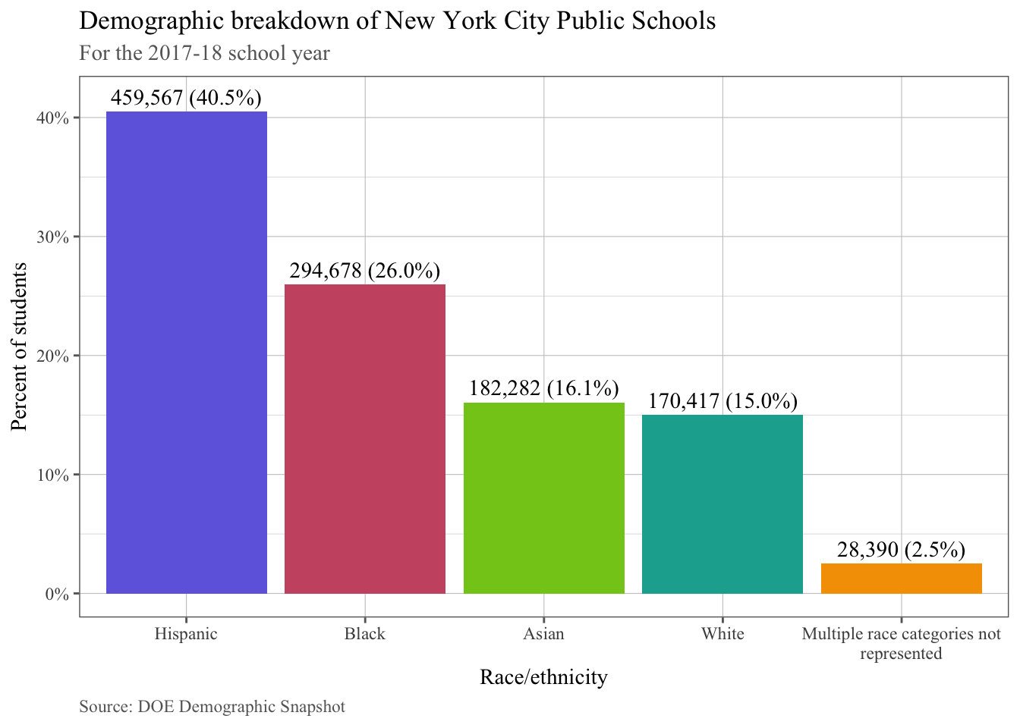

Despite this overall diversity, most New York City schools do not reflect the diversity of the public school system as a whole. Based on a review of data provided by the DOE pursuant to Local Law 59 of 2015 (the School Diversity Accountability Act), for the 2017-18 school year, 74.6% of black and Hispanic students attended a school that was less than 10% white, and 34.3% of white students attended a school with more than 50% white students.
As previously mentioned, in addition to race, DOE schools are also segregated by socioeconomic status. As illustrated in Chart 2, for the 2017-18 school year, 74.5% of Hispanic students, 71.8% of black students, and almost 50% of Asian students attended a school where more than 75% of their classmates experienced poverty. Conversely, only 24.9% of white students attended a school where more than 75% of their classmates experienced poverty. Citywide, 74% of students experience poverty and the citywide ENI is 70.7%.

Chart 2
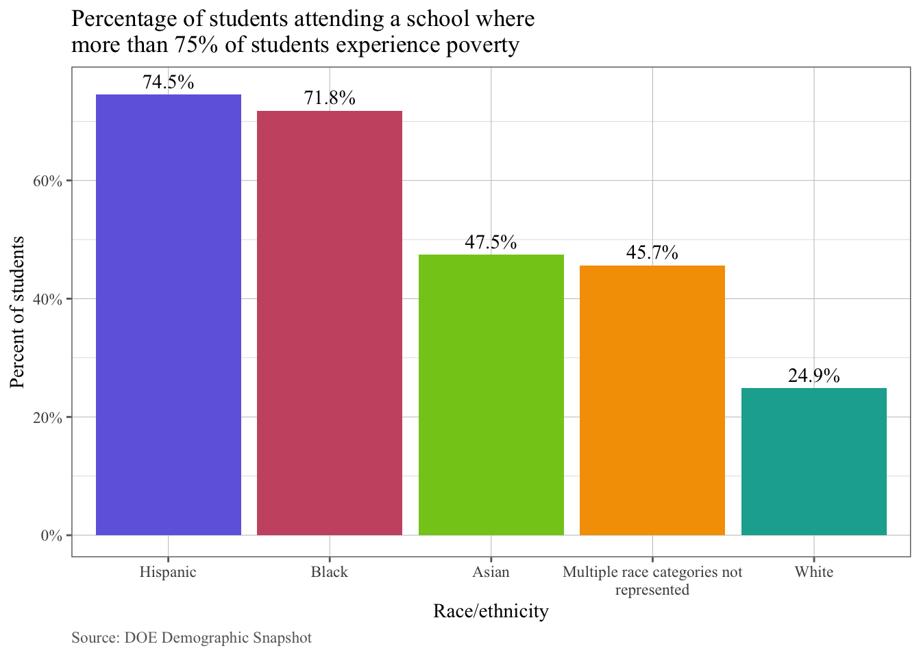
While race and socioeconomic status are important considerations when evaluating schools for diversity, other factors such as diversity among English language learners (ELLs), students with disabilities (SWDs), and students living in temporary housing (STH) should also be considered. An analysis of DOE’s 2017-18 demographic data shows that while 25.2% of schools have a population of more than 20% ELL students, 47.4% of schools had a population of less than 10% ELL students. In addition to this discrepancy, SWDs were also under-represented in many schools. In fact, while 19.7% of students citywide were SWDs, 6.06% of schools have a population that is less than 10% SWDs. Furthermore, STHs were overrepresented in some schools and underrepresented in others. While 29.2% of schools have a population of more than 15% of STHs and 4.63% of schools do not have any STH.
Impact of School Zoning and Choice on School Segregation
Many schools, known as “zoned” schools, admit students based solely on residence in a specific school attendance zone. At the elementary level, 29 out of the City’s 32 community school districts are divided into attendance zones, and the other three, District 1 (Manhattan), District 7 (Bronx), and District 23 (Brooklyn), are “choice” districts, which have no zoned schools. Citywide, there are more than 100 zoned middle grade schools, and most students attend their zoned middle school or a school within their community district. Therefore, elementary - and, to an extent, middle school - students living in a segregated community are highly likely to attend a segregated zoned school. Notably, while some high schools consider zoning during admissions, there are not a significant number of zoned high schools in NYC.
While neighborhood school zoning has a significant role in school segregation, research shows “school choice” further exacerbates school segregation. School choice gives students the option to attend a school other than their local public school, including private schools, charter schools, and public schools outside of their district. As reported by the Center for New York City Affairs at The New School, students who participate in choice usually attend schools with higher test scores and fewer low-income students. In contrast, students who attend their zoned schools are more likely to attend schools with higher concentrations of poverty and a higher number of peers who are multi-lingual learners.
While all ethnic groups and races exercise school choice at higher rates than they did 10 years ago, research shows that certain groups are more prone to participate in school choice. Almost 60% of black students opt out of their neighborhood, zoned school, up from 38% a decade ago, and in 2016-17, 39% of Hispanic students opted out of their zoned school. Unlike their black and Hispanic peers, Asian and white students are less likely to opt out of their neighborhood school, as they are more likely to be pleased with their zoned neighborhood schools. Additionally, students who are eligible for free lunch and ELLs are less likely to opt out of their zoned schools than their higher income and English-proficient peers.
The Center for New York City Affair’s analysis found that living in gentrifying communities is the largest predictor of choice out of all other student characteristics analyzed in their research, i.e. taking advantage of school choice. In fact, students residing in gentrifying communities are 1.7 times more likely to exercise school choice than students living in non-gentrifying communities. White students in gentrifying neighborhoods exercised school choice significantly more than whites who were in non-gentrifying neighborhoods, with 46% of whites in gentrifying neighborhoods opting out of their zoned school, compared to 25% of them opting out in non-gentrifying neighborhoods.
Research shows that if all elementary students attended their zoned school, although the school system would still be segregated, it would be less segregated than it is currently. Moreover, more than 6,000 additional kindergarteners would be enrolled in schools with free lunch rates that correlate with the City’s average, and approximately 2,300 additional kindergarteners would be enrolled in schools that are between 50 and 90% black and Hispanic. Additionally, students would be more equally distributed by language status, race, and income level throughout the education system.
Impact of Screened Schools on School Segregation
Many middle schools and most high schools are unzoned; therefore, applicants have more flexibility to choose the schools they prefer to attend. Some researchers, however, argue that this process perpetuates racial segregation due to the screening processes used. Screening processes allow schools to evaluate students based on auditions or other criteria such as their grades, standardized test scores, and attendance. Moreover, these criteria limit choice for students who are struggling academically and students who have challenging behavior. During school year 2017-18, of NYC’s 277,521 high school students, 15% attended schools with academic screens and 40% attended unscreened schools. About 18% of middle school students attended screened schools and 52% attended unscreened schools.
“Limited unscreened schools,” which unlike screened schools do not consider academic and attendance records, grant priority to students who have attended a school’s open house event, table at a high school fair, or information session. DOE acknowledges that such requirements may be an obstacle for parents who work long hours and who therefore cannot attend such events with their students. Moreover, students with high needs are less likely to be matched with a high-demand and high-performing limited unscreened school.
As reported by the Center for New York City Affairs at The New School, black and Hispanic students are concentrated in unscreened schools and Asian and white students have a higher likelihood of attending a screened school.
Specialized High Schools
The nine Specialized High Schools are New York City’s most prestigious public schools, with students scoring at the 99th percentile of the state SAT distribution and accounting for the majority of NYC students attending Harvard, Princeton, and Yale. In 1971, a State law known as the Hecht-Calandra Act was passed with the purpose of blocking the diversification of the elite schools by requiring that admission to the schools “be solely and exclusively” gained by taking a specialized, voluntary admissions test, which is called the Specialized High Schools Admissions Test (SHSAT).
The sponsors of the legislation, Senator John D. Calandra (R-BX) and Assemblymember Burton G. Hecht (D-BX) asserted at the time of introduction that the bill was motivated by “the most insidious attack thus far upon the finest educational schools in New York City. [The Chancellor’s…] attempt to destroy these schools must be stopped immediately.” Early in 1971, only two years after a NYC teachers strike and the new decentralization law, the superintendent of one of the new NYC community school districts, Alfredo O. Mathew, Jr., of District 3 in Manhattan’s Upper West Side, asserted that Bronx High School of Science “…was a privileged educational center for children of the white middle class because ‘culturally’ oriented examinations worked to ‘screen out’ black [sic] and Puerto Rican students who could succeed at the school.” On these grounds of racial discrimination, the Superintendent and his local school board members asked the Chancellor’s office (then Chancellor Harvey Scribner) to change the policy to eliminate the entrance examination and to move to admission based on the recommendation of elementary school personnel. At the time, the Chancellor asserted “there is a questions as to the extent any test of academic achievement tends to be culturally biased.” He announced he would appoint a committee to examine the admissions procedure. These actions precipitated the legislative responses by Calandra and Hecht.
The law named three test-in specialized schools (Stuyvesant, Bronx Science, and Brooklyn Tech), and “such further high schools which the Board of Education may designate from time to time.” Today, eight schools continue to operate as exam schools; the original three as well as Brooklyn Latin School; Staten Island Technical High School; Queens High School for the Sciences; High School of American Studies; and the High School of Mathematics, Science and Engineering. Fiorello H. LaGuardia High School of Music & Art, does not use the test but rather admits students on the basis of auditions and students' academic records.
On March 18, 2019, students across the city received high school offer letters. According to DOE, approximately 27,500 8th graders took the SHSAT this year. A total of 5,830 students received an offer to one of the City’s nine specialized high schools. Of those, 4,798 received an offer to a specialized high school based on their exam score and 1,432 students received one or more offers to programs at LaGuardia. The distribution of offers by ethnicity was: 51.1% Asian; 28.5% white; 6.6% Hispanic, 4% black; 2.3% Multi-racial; and 7% Unknown.
The lack of representation of the racial makeup of the City’s schools system in the admissions offers to the test-based specialized high schools is also reflected in the overall student bodies for these schools. See Chart 3 below.

Chart 3
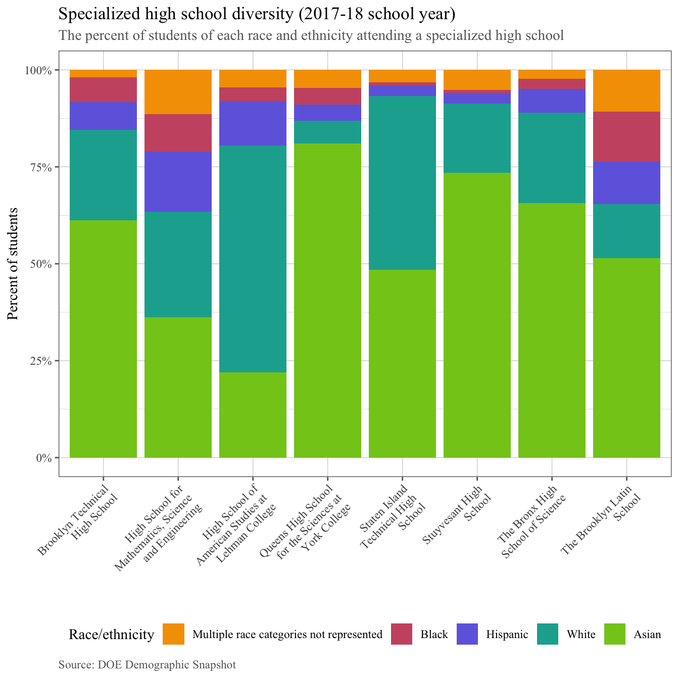
These inequities exist despite DOE’s recent enhanced test preparation and outreach efforts to increase diversity of the specialized high schools. In 2019, approximately 2,300 8th graders participated in the DREAM program, as compared with approximately 1,800 students in 2018. The DREAM (Determination, Resiliency, Enthusiasm, Ambition, Motivation) program is an extracurricular academic program that prepares eligible New York City public school students for the SHSAT. DREAM participants comprised 10% of black and Hispanic testers, but 29% of black and Hispanic offers. Additionally, DOE expanded SHSAT School Day, a program that offers the SHSAT during the school day, to 50 middle schools, up from 15 the prior year. Furthermore, DOE continues its Discovery program, which is a summer program that supports high-need students who obtained a SHSAT score within a certain range below the minimum cut off score to be admitted to a specialized school. According to the DOE, by the summer of 2020, 20% of seats at each specialized high school will be reserved for participants of the Discovery program.
Table 1 below contains the ENI for each of the test-based specialized high schools. For context, the citywide ENI is 70.7%.

Table 1
School | % of Students Experiencing Poverty | Economic Need Index
Stuyvesant High School | 44.3% | 41.8%
High School for Mathematics, Science and Engineering | 42.6% | 41.5%
The Bronx High School of Science | 44.2% | 39.5%
High School of American Studies at Lehman College | 20.3% | 24.1%
Brooklyn Technical High School | 60.8% | 52.0%
The Brooklyn Latin School | 61.7% | 52.7%
Queens High School for the Sciences at York College | 60.5% | 47.1%
Staten Island Technical High School | 40.8% | 35.1%
A detailed analysis of funding for the specialized high schools can be found in Appendix B.
State and City Efforts to Increase School Diversity
New York State Education Department Integration Programs
New York State Education Department Socioeconomic Integration Pilot Program
In December 2014, the New York State Education Department’s (NYSED) announced a grant program, the Socioeconomic Integration Pilot Program (SIPP), to improve student achievement in up to 25 of the state’s low-performing “Priority” and “Focus” schools by encouraging greater socioeconomic integration in these schools. Funded with federal Title I dollars, the SIPP grant program, running from 2015-18, allocated up to $1.25 million over three-years to each participating school “to pilot innovative programs to increase school diversity while improving student achievement.” Eligibility for the grant was restricted to Title I Focus low-performing districts with poverty rates of at least 60% and at least 10 eligible low-performing schools. Larger districts were eligible to receive more grants, with New York City eligible for the greatest number, eight schools. SIPP grant recipients were required to implement one of several models intended to increase the achievement of low-income students and attract higher-income students, which included high-demand programs such as dual language, arts, STEM and career pathway programs.
New York State Integration Project Grant
In 2018, NYSED launched another grant program to support integration efforts, the New York State Integration Project (NYSIP) Grant, which also uses Federal School Improvement funds. The purpose of the NYSIP program is to improve student achievement “by encouraging greater racial/ethnic, special education, English Language Learner/Multilingual Learner (ELL/MLL), and socioeconomic integration” in Title I schools identified for improvement. NYSIP is a three-phase program designed to provide districts with “the funding and support to 1) learn about the benefits of integration and develop a sustainable integration strategy for the district, 2) refine their strategy and implement a limited pilot, and 3) fully implement a district integration plan.”
The current phase of the program, Phase I, is called the Professional Learning Community (PLC), which is intended to provide participants with tools, information, and funding “to successfully design integration strategies tailored to the district’s communities.” Phase I is a non-competitive grant, ranging from $50,000- $68,000 per participating district based on number of students in the district. Grant funds are intended to pay for full participation of district representatives in the PLC learning and working meetings (including travel and lodging costs) and any remaining funds can be used for planning, data gathering, community engagement, and staff time to develop each participant’s integration strategy. Eligibility for Phase I is restricted to districts identified as Title I Focus Districts that have at least one Priority or Focus School and have a district poverty rate of 50%. NYSED established a list of eligible districts, including 15 Community School Districts (CSDs) in New York City (CSDs 1, 2, 3, 10, 13, 15, 20, 21, 22, 24, 25, 27, 28, 30 and 31). On May 7, 2018 the list of grant awardees was announced, including 14 of the 15 eligible CSDs in New York City (CSD 25 was not a grant recipient).
Phase II of the program is competitive and designed to allow participants to pilot the integration strategies that they designed in Phase I. Grant funding will be used to “hire consultants or use staff time to model, conduct focus groups, or otherwise test their integration plans; conduct community engagement; and take such other actions as may be necessary to successfully pilot the integration plan developed in Phase I.”
Phase III is also competitive and designed to help participants fully implement the specific integration strategies that the district developed in Phase I and then piloted and refined in Phase II. Because Phases II and III of the grant process are competitive, there will be fewer participants in each subsequent phase, so Phase II and Phase III participants can expect increased financial and technical support from NYSED.
DOE Efforts to Increase School Diversity
DOE’s Diversity Plan
In June 2017, DOE released its Diversity in New York City Public Schools plan, which outlines DOE’s approach to increase diversity in DOE schools. The plan includes a policy statement articulating DOE’s commitment to school diversity and belief that all students benefit from diverse and inclusive classrooms. The plan also identifies the following three initial goals for making schools more diverse and inclusive:
- Increase the number of students in a “racially representative” school by 50,000 over the next five years;
- Decrease the number of “economically stratified” schools by 10% (150 schools) in the next five years;
- Increase the number of “inclusive” schools that serve English Language Learners and Students with Disabilities.

DOE defines a school as “racially representative” if black and Hispanic students together represent between 50% and 90% of the school’s student population, given that black and Hispanic students comprise approximately 70% of the citywide student population. Based on that definition, DOE reported that 30.7% of schools were racially representative in 2017, when the plan was released.
DOE considers a school “economically stratified” if its economic need, as measured by the DOE’s Economic Need Index, is more than 10 points higher or lower than the City average. A school can be classified as economically stratified if it has a higher concentration of either high-income or low-income students.
Finally, DOE defines “inclusive schools” as those where a “significant, representative number” of ELLs and SWDs are “are welcomed and served effectively.”
In addition to setting diversity goals, the plan included the following 12 proposals to improve school diversity:
- Eliminate “limited unscreened” as a high school admissions method and replace with admissions methods that will promote greater diversity.
- Develop strategies to increase access to screened schools for all students, especially high-needs students.
- Streamline the formal mechanisms for families to learn about school options and apply.
- Expand Diversity in Admissions pilots.
- Evaluate efforts from the Students in Temporary Housing admissions pilot and propose a revised plan.
- Analyze and expand the Specialized High Schools diversity initiatives.
- Plan for diversity when opening new, high-quality schools and programs.
- Ensure diversity is a factor in school rezoning and improve the rezoning process to deepen engagement with communities.
- Target funding, including magnet grant funding, to foster diversity.
- Foster welcoming school climates for all students by continuing and expanding school discipline reform.
- Increase participation of underrepresented students in STEM and rigorous courses.
- Improve all schools through the Equity and Excellence for All agenda.

Finally, DOE’s plan announced the formation of a School Diversity Advisory Group (SDAG), which includes a wide range of educational stakeholders to “tackle citywide policies and practices such as admissions and program planning.” The SDAG was tasked with evaluating DOE’s initial goals and policies on diversity and with making recommendations to the Mayor and Chancellor on citywide practices and policies and on the long-term governance structure for diversity work.
The SDAG released its initial report, Making the Grade: The Path to Real Integration and Equity for NYC Public School Students, in February 2019. The report offers an extensive list of recommendations, some of which address DOE’s existing diversity plan, urging that that DOE be more aggressive and more realistic with short-term, medium-term, and long-term goals. The remaining recommendations are organized under the framework developed by the youth-led organization IntegrateNYC, called the 5Rs of Real Integration: Race and Enrollment, Resources, Relationships, Restorative Justice & Practices, and Representation. (See Appendix C for a summary of key SDAG recommendations.) The SDAG plans to release another report with additional recommendations by the end of this school year, further addressing such issues as school screens, gifted and talented (G&T) programs, and school resources.
Diversity in Admissions Pilot Program
In November 2015, DOE announced a new Diversity in Admissions pilot program initiated in seven elementary schools. These schools gave priority in their admissions processes to students who qualified for FRPL, ELLs, and/or those in the child welfare system or impacted by incarceration. After the initial pilot, DOE gave all schools the opportunity to apply for the program starting in spring 2016 and by the following fall, 12 more schools, including several middle and high schools, joined the pilot. According to DOE’s website, “[m]ore than 75 NYC public schools and programs are participating in Diversity in Admissions pilots this year.” Participating programs span Pre-K, elementary, middle and high schools and include some G&T programs. Each program sets its own admissions priorities for students who are FRPL -eligible, ELLs, in the child welfare system, impacted by incarceration, or in temporary housing.
Districtwide Diversity Programs
In October 2017, DOE announced that District 1, including the Lower East Side and East Village of Manhattan, would implement the City’s first districtwide Diversity in Admissions pilot. This plan includes a Family Resource Center, which opened in October 2017, to assist families with the enrollment process for District 1 schools. Through the District 1 pilot program, pre-K and kindergarten students who qualify for FRPL, live in temporary housing, or are ELLs will receive priority in 67% of offers at every elementary school in the district. Students who are not in these categories will receive priority for the remaining 33% of offers. Additionally, the pilot program will ensure that every district elementary school will “make Kindergarten offers to a percentage of SWDs near the district average within the 67% and 33% priorities.”
District 3, which spans the Upper West Side of Manhattan and part of Harlem, also adopted a districtwide Diversity in Admissions plan for middle schools for the upcoming 2019-20 school year. The District 3 plan gives admissions priority for 25% of seats to low-income students with lower academic performance. According to DOE data, 13 of the district’s 16 participating middle schools moved closer towards the goal of making 25% of offers to the priority groups.
Additionally, in September 2018, Mayor Bill de Blasio and Schools Chancellor Richard Carranza announced approval of a proposed middle school diversity plan submitted by District 15 in Brooklyn after a year-long community-driven process. District 15’s planning process was led by a 16-member Working Group, including District 15 educators, parents, a Community Education Council member, advocates, and representatives of community-based organizations, and was facilitated by the urban planning firm WXY. The Working Group released final recommendations in August 2018 after conducting four public workshops, several additional meetings, and community outreach. The District 15 plan for middle school diversity will remove screens from all middle schools, and will prioritize 52% of 6th-grade seats for students from low-income families, ELLs, and STH. Previously, 10 of 11 District 15 middle schools used a screened admissions method, under which they considered students’ grades, test scores, attendance, and/or other factors in admissions. The City will invest $500,000 to support the admissions changes, including creation of a Middle School Admissions Coordinator position and Outreach Team, as well as a Diversity, Equity, and Integration Coordinator position and funding for teacher training and arts, technology, and other supports for middle schools in the district. Preliminary results for the upcoming 2019-20 school year indicate that nine of the 11 District 15 middle schools met the target range of 40-75% of offers going to high-needs students.
Finally, the Mayor and Chancellor also announced a $2 million school diversity grant program to enable approximately 10 other school districts to develop their own community-driven diversity plans. “The $2 million will primarily be used to support community planning processes similar to the one in District 15, including engaging community planning firms with expertise in this work, selecting and developing Working Groups, hosting community meetings and providing materials and translation, and developing final proposals.”
Specialized High Schools Diversity Proposal
In June 2018, Mayor de Blasio and Chancellor Carranza announced a plan to make admissions to the Specialized High Schools fairer and to improve diversity. The plan consists of two parts: expanding the Discovery Program to help more disadvantaged students receive an offer and eliminating the use of the single-admissions test over three years. The Administration plans to expand the Discovery Program to 20 percent of seats at each Specialized High School over two years, beginning in September 2019 and adjust the eligibility criteria to target students attending higher poverty schools. Additionally, the Administration proposed to phase out the single admissions test as the criteria for admissions by allocating seats to top performers from each middle school. By the end of year three of the phase out period, the Administration plans to eliminate SHSAT and reserve approximately 90-95 percent of specialized high school seats for the top seven percent of students at each middle school. Other students, including those in non-public schools, would be able to opt into a lottery for the remaining seats. Notably, the State would need to change the admissions criteria of the specialized high schools. There is already state legislation introduced that would make this change, A.10427-A by Assemblymember Barron.
New York City Council Efforts to Improve School Diversity
The Council has taken several steps to advance diversity in City schools. In 2015, the Council passed its School Diversity Accountability Act, Local Law 59. This law requires DOE to report annually student demographic data disaggregated by CSD, school, and special program within a school. Additionally, Local Law 59 requires DOE to report on its efforts during the previous school year to “encourage a diverse student body in its schools and special programs, including, but not limited to, strategic site selection of new schools and special programs, making recommendations to the community education council to draw attendance zones with recognition of the demographics of neighborhoods, the allocation of resources for schools and special programs, and targeted outreach and recruitment efforts.” In 2015, the Council also adopted a resolution calling upon DOE to officially recognize the importance and benefits of school diversity and to set it as a priority when making decisions regarding admissions policies and practices, creation of new schools, school rezoning, and other pertinent decisions and commit to having a strategy in each district for overcoming impediments to school diversity.
In 2017, the Council announced that it would allocate funds to support culturally responsive education training for DOE teachers through two programs: NYU Metro Center’s Critically Conscious Educators Rising Series and Border Crossers. The Council also adopted a resolution calling upon New York State to convene a task force to assess the cultural relevance of state learning standards across subject areas in elementary, middle, and high school and explore the grounding of standards in core content that challenges racism, ableism, and sexism, and is lesbian, gay, bisexual and transgender and transgender and gender non-conforming-affirming.
More recently, on March 28, 2019, NYC Council Speaker Corey Johnson released an op-ed in Chalkbeat, outlining the following pieces of legislation to address school segregation citywide:
- Legislation that would require DOE to participate in district diversity working groups in each district. Consisting of students, parents, teachers, principals, administrators, and community advocates as well as a community based organizations (CBOs) and DOE central staff, these working groups would work with CBOs to facilitate the creation and publishing of public-input integration plans in every school district.
- Legislation that would codify the mayoral school diversity advisory group. The advisory group, which would include Council, Mayoral and DOE appointees, would be tasked with examining all factors as they relate to school diversity and would be required on an annual basis to provide a public report to the mayor and the speaker on progress made to increase diversity in all schools.
- Legislation that would create a Council-DOE led task force that would be charged with addressing the racial/ethnic student body inequities of the eight test-based specialized high schools. The task force, which would work with the school diversity advisory group would be required to develop recommendations for new admissions criteria.

In addition to the aforementioned legislation, Speaker Johnson also called for the elimination of the specialized high schools’ single admissions exam and the creation of additional City-designated elite high schools. Additionally, Speaker Johnson called for DOE to revamp and restore full G&T programs in every school district.
Issues and Concerns
The City’s public school student population is economically, racially, and linguistically diverse; however, such diversity is not often reflected in individual schools and districts. This is of great concern because a considerable body of research indicates that racial, cultural, and economic diversity of schools is strongly associated with a range of short- and long-term benefits for all students. That specialized high schools fail to reflect the diverse citywide student population is also very concerning. These highly competitive schools provide students with access to the best universities in the country and provide students with various resources that correlates with academic success, and such opportunities should not be limited to a select few populations.
Concerns about DOE’s Diversity Plan
DOE has launched numerous initiatives to increase diversity in NYC public schools; however, advocates have highlighted several concerns about DOE’s Diversity Plan.
In its Diversity Plan, DOE defines “racially representative” schools as those in which black and Hispanic students combined make up at least 50% but no more than 90% of the student population. However, critics contend that this definition is problematic, since most of the academic literature on school segregation classifies schools that are 90% black and Hispanic as “intensely segregated.”
Additionally, some researchers argue that DOE’s plan is “unambitious” According to researchers at the Center for New York City Affairs at The New School, “if recent demographic shifts that have occurred in our schools merely continue apace for the next five years, the DOE will be able to meet these diversity goals without implementing a single one of the dozen policies they recommend in their new plan.” For example, even without implementing DOE’s Diversity Plan, the number of racially representative schools is increasing, primarily because of a citywide decrease of black students and an increase of the number of Asian and white students.
While DOE’s launch of numerous diversity pilot programs demonstrates an effort to diversify City schools, many challenges need to be considered as DOE moves forward with this process.
One major challenge is that of ensuring that all students, regardless of their background, feel included and valued in their schools. Research shows that overall, school curriculum and instruction is presented from a white male perspective, and numerous advocates have pushed for a more culturally responsive education in public schools. Additionally, research shows that black and Hispanic students are disproportionately suspended from schools in comparison to their Asian and white peers. It is imperative that all schools, including schools being integrated, have fair and just discipline polices.
Another challenge has been the lack of a sizable constituency clamoring for school integration. Until the recent release of data on specialized high school admissions and ensuing media coverage prompted controversy and debate, other issues such as school funding, school climate and safety, overcrowded classrooms, standardized testing, and other local issues loomed larger for parents and communities than school segregation. In fact, some parents and communities have actively opposed integration efforts, and efforts to decrease segregation through school rezoning have triggered fierce resistance in some cases. A District 3 rezoning plan to reduce overcrowding at two schools on the Upper West Side, which enroll mostly white and Asian students, to a third school, which enrolls mostly black and Hispanic children from public housing across the street, generated swift backlash. In other cases, parents are fearful that an influx of higher income students in schools in gentrifying neighborhoods will jeopardize the school’s federal Title I funding.
Pre-Kindergarten (Pre-K)
Another area of concern is the lack of diversity in pre-kindergarten (pre-K) classrooms, especially considering the Mayor’s efforts to expand Pre-K for All. According to the Century Foundation, UPK classrooms are “more likely than kindergarten classrooms to have a racial majority in excess of 90 percent.” Further, even in diverse neighborhoods, segregation persists in Pre-K programs.For example, in Bensonhurst, Brooklyn, there are four pre-K programs just a few blocks from each other, but each program’s demographics varies significantly: two of the programs are predominately white, one is 100% Asian, and one is evenly representative of Hispanic, Asian, and white students.
Conclusion
Today’s hearing will provide an opportunity for the Committees to examine DOE’s efforts to combat segregation throughout the public school system. The Committees also expect to hear testimony from parents, students, educators, advocates, unions, and other members of the public about their concerns and recommendations for increasing diversity in NYC public schools.

APPENDIX A

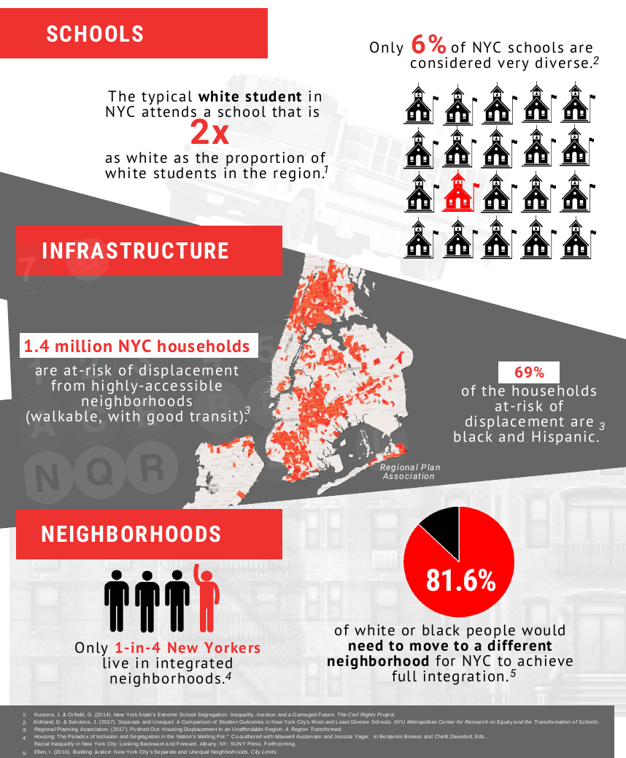
Source: “Desegregating NYC. Twelve Steps Toward a More Inclusive City,” A Report by Council Member Brad Lander. April 2018, page 3. Accessed at: https://drive.google.com/file/d/17yqKmyjsVXJEezRc-Dxfiz08F8C3MW_n/view

APPENDIX B
Funding For Specialized High Schools
There are three major budget allocations that support the administration of the Specialized High Schools Admissions Test (SHSAT), SHSAT test prep, and the Specialized High Schools themselves.
Contract for SHSAT. DOE contracts with NCS Pearson, Inc. for the SHSAT. The $13.4 million contract covers five testing cycles over a six-year period beginning November 1, 2016 and ending October 31, 2022; there is an option for two one-year extensions. While the average annual cost of the contract is $2.2 million, the contract costs were highest in the first year: $3.5 million, and are expected to be lowest in the final year: $1.1 million. The contract was approved by the Panel for Education Policy (PEP) on September 21, 2016.
DREAM Program, Diversity Program, and SHSAT School-day Administration. According to DOE testimony at the Fiscal 2020 Preliminary Budget hearing on March 20, 2019, the Department spends approximately $500,000 annually on the Discovery program, and approximately $2.5 million annually on the DREAM program. In addition, according to Fiscal 2019 School Allocation Memorandum Number 76, “Specialized High School Admissions Testing,” the DOE spent $778,254 on the administration of the SHSAT at eight testing sites, and $167,408 on SHSAT after-school test prep and administration at the 50 schools that offer the SHSAT during the school day, part of the SHSAT School Day Initiative.
“Specialized Academic” Fair Student Funding Weight. Each Specialized High School receives an additional “Specialized Academic” weight through the Fair Student Funding (FSF) formula. The weight is currently 0.25 of the per capita student funding, which in Fiscal 2019 amounts to an additional $1,020.68 per student. However, of the eight specialized high schools that use the SHSAT for admissions, four are receiving less than their FSF entitlement (that is, their FSF funding level is less than 100 %) and four are receiving more than their FSF entitlement (that is, their FSF funding level is higher than 100 %). Some schools receive more than 100 % because when the Department of Education (DOE) began using the FSF formula to fund schools they made a decision not to cut the amount of funding schools received before this formula was used.
The table below shows the amount of additional FSF funding each specialized high school is receiving as a result of the “specialized academic” weight in the current fiscal year.
School | FY19 Per Capita for "Specialized Academic" | FY19 Enrollment | "Specialized Academic" Spending if FSF 100% | FSF % | "Specialized Academic" Spending Given FSF %
Stuyvesant HS | $1,020.68 | 3,298 | $3,366,211 | 96.66% | $3,253,780
Brooklyn Tech | $1,020.68 | 5,970 | $6,093,475 | 90.00% | $5,484,128
Bronx Science | $1,020.68 | 3,004 | $3,066,131 | 90.00% | $2,759,518
Brooklyn Latin | $1,020.68 | 616 | $628,741 | 100.41% | $631,319
Staten Island Tech | $1,020.68 | 1,335 | $1,362,611 | 97.44% | $1,327,728
Queens HS for Sciences | $1,020.68 | 473 | $482,783 | 106.67% | $514,985
HS of American Studies | $1,020.68 | 409 | $417,459 | 113.85% | $475,277
HSMSE | $1,020.68 | 512 | $522,590 | 121.25% | $633,640
 | TOTAL | 15,617 | $15,940,001 |  | $14,446,734
Prepared by the New York City Council Finance Division, March 22, 2019
APPENDIX C

Summary of the School Diversity Advisory Group Report

In June 2017, as part of the Department of Education’s (DOE) Diversity in New York City Public Schools plan, the DOE established a School Diversity Advisory Group (SDAG) to make formal policy recommendations to the Mayor and Chancellor relating to increasing diversity in schools. In February 2019, the SDAG released its initial report, Making the Grade: The Path to Real Integration and Equity for NYC Public School Students. The SDAG’s first recommendations address DOE’s existing diversity plan, with the remainder organized under the framework developed by the youth-led organization IntegrateNYC, called the 5Rs of Real Integration: Race and Enrollment, Resources, Relationships, Restorative Justice & Practices, and Representation. (Note that the SDAG plans to release another report with additional recommendations by the end of this school year, including such issues as school screens, gifted and talented (G&T) programs, and school resources.) The report was silent on the issue of diversity at the City’s specialized high schools.

Key Recommendations

DOE 2017 Diversity Plan: Goals, Metrics, & Accountability
SDAG recommends that DOE be more aggressive and more realistic with short-term, medium-term and long-term goals.
- Short-term: Elementary and middle schools should be measured against their district’s racial, economic, Multilingual Learner (MLL), and Students with Disabilities (SWD) percentages.
- Medium-term: Upon meeting district-level targets, individual schools should work towards reaching their borough percentages.
- Long-term: DOE should aim for all schools to look more like the city.
- Create a Chief Integration Officer position.
- Add metrics to School Quality Report related to Diversity and Integration.

Race, Socioeconomic Status & Enrollment
Support more equitable admissions processes so more schools and classrooms reflect the city’s diversity.
- Require all nine school districts with sufficient demographic diversity of population to develop diversity and integration plans (Districts 1, 2, 3, 13, 15, 22, 27, 28, 31).
- All Family Welcome Center staff should be trained to support students with disabilities and should be prepared to help students consider all school options within their community.
- School staff should be trained to welcome and accommodate students and family members with disabilities as well as immigrant families, who need interpreters at school fairs and tours.

Resources
The DOE must address funding formulas that lead to uneven distribution of money and, therefore, inequitable opportunity in schools’ programs, staff and facilities.
- In September 2018, DOE announced a $2 million school diversity grant program for districts to develop community-driven diversity plans. DOE should expand this funding if it receives more applications than the $2 million can support and consult the SDAG on the roll-out of the grant. (It is unclear whether this grant will fund the nine districts that SDAG would “require” to develop diversity and integration plans.)
- Support efforts in Albany to collect Campaign for Fiscal Equity funding owed to City schools.
- Launch a Task Force to recommend equitable PTA fundraising strategies.
- Invest in programming that intentionally creates diverse populations, e.g. dual language programs and integrated learning environments for students with disabilities to ensure that programs will be attractive to a broad cross section for families in a community.
- Invest in program offerings to ensure high poverty schools have the same curricular, extra-curricular and after school opportunities as schools in more affluent communities.
- Invest in growing and strengthening high-performing schools outside of Manhattan.

Relationships
Relationships between students, parents, teachers, and other school staff play an important role in creating environments where all students feel supported and empowered and learn from each other.
Student Empowerment
- Every school should have the resources for a high-quality student council.
- Expand Borough Student Advisory Councils to include representatives from every high school.
- Create a Student Leadership Team, comprised of one student from each BSAC to meet monthly with the Chancellor.
- A General Assembly should be created with representatives from every high school to develop a citywide student agenda and vote on key issues.
- Create a new leadership position within the central DOE office to focus on student voice.
- Create a standing committee on high school admissions to advise the Chancellor.

Pedagogy & Curriculum
- Provide culturally responsive pedagogical practices at all schools and for all students.
- Create partnerships with institutions of higher education to ensure Culturally Relevant Education (CRE) is an essential component of all pre-service teacher training efforts.
- Work with the NYS Education Department to utilize CRE as part of teacher certification and to secure additional funding to train and support teachers and staff in CRE.
- Work with vendors who supply Culturally Responsive instructional materials and training.

School Climate
- Assess the roles and responsibilities of School Safety Agents (SSA) in school communities.
- Analyze the benefits and drawbacks of moving SSAs to DOE supervision from NYPD supervision.
- Require all schools to monitor student discipline practices and develop a plan to reduce disparities in how students are disciplined.
- Expand community schools initiative and other models that connect schools to community based organizations.
- Include school climate metrics on Quality Review/Comprehensive Education Plan (CEP) Goals.

Parent & Teacher Empowerment
- Utilize varied outreach efforts to meaningfully engage parents in school decision-making processes with the goal of including families that have not participated in prior activities.
- Ensure that Individualized Education Programs (IEPs) are translated and provide interpretation and translation support for IEP-related meetings.
- Support current efforts to share best practices between teachers, administrators and parents on CRE, school climate, and parent empowerment.

Restorative Justice & Practices
The SDAG endorses the recommendations of the Mayor’s Leadership Team on School Climate and Discipline and calls on DOE and its partner agencies to provide an update on implementation of these recommendations.

Representation
DOE should further its efforts to create a diverse workforce and expand its definition of diversity to include all race and ethnicities, cultural backgrounds, gender identities, languages, and abilities.
- Report diversity of staff by position as part of the school quality report.
- Monitor workforce diversity on race, ethnicity, disability, gender identity, and sexual orientation.
- Launch a task force to investigate the current state of the DOE’s workforce and recommend best practices learned from existing efforts and from other school districts and sectors.
- Explore career pipeline opportunities for school staff and for high school students.

347 U.S. 483.
“Brown v Board of Education Decision (May), Civil rights Movement Veterans. Accessed at: https://www.crmvet.org/tim/timhis54.htm#1954bvbe.
Shapiro, E. “Segregation Has Been the Story’s of New York City’s Schools for 50 Years,” The New York Times. March 26, 2019, accessed at: https://www.nytimes.com/2019/03/26/nyregion/school-segregation-new-york.html.
Harris, A. “Can Richard Carranza Integrate the Most Segregated School System in the Country?” The Atlantic. July 23, 2018, accessed at: https://www.theatlantic.com/education/archive/2018/07/richard-carranza-segregation-new-york-city-schools/564299/.
Shapiro, E. “Only 7 Black Students Got Into Stuyvesant, N.Y.’s Most Selective High School, Out of 895 Spots,” The New York Times. March 18, 2019, accessed at: https://www.nytimes.com/2019/03/18/nyregion/black-students-nyc-high-schools.html.
Stuyvesant High School, Bronx High School of Science, Brooklyn Technical High School, Brooklyn Latin School, Staten Island Technical High School, Queens High School for the Sciences, High School of American Studies, the High School of Mathematics, Science and Engineering, and LaGuardia High School of Music and the Arts.
N.Y. Ed Law § 2590-h.
Shapiro, E. “Only 7 Black Students Got Into Stuyvesant, N.Y.’s Most Selective High School, Out of 895 Spots,” The New York Times. March 18, 2019, accessed at: https://www.nytimes.com/2019/03/18/nyregion/black-students-nyc-high-schools.html.
The ninth, LaGuardia High School of Music and the Arts, admits students on the basis of auditions and students' academic records.
See New York City Department of Education. “Re: High School Admissions.” 19 March 2019. E-mail from DOE on file with Council staff
See New York City Department of Education, “DOE Data at a Glance.” Accessed at: https://www.schools.nyc.gov/about-us/reports/doe-data-at-a-glance.
Chen, M. “New York’s Separate and Unequal Schools.” The Nation. February 20, 2018, accessed at: https://www.thenation.com/article/new-yorks-separate-and-unequal-schools/.
Harris, E. and Katz, J, “Why are New York’s Schools segregated? It’s Not as Simple as Housing.” The New York Times. May 2, 2018, accessed at: https://www.nytimes.com/interactive/2018/05/02/nyregion/new-study-school-choice-increases-school-segregation.html/.
“Current Campaign: Enrollment Equity,” Teens Take Charge, accessed at https://www.teenstakecharge.com/campaign.
John Kuscera with Gary Orfield, “New York State’s Extreme School Segregation: Inequality, Inaction, and a Damaged Future.” The Civil Rights Project. March 2014, accessed at: http://civilrightsproject.ucla.edu/research/k-12-education/integration-and-diversity/ny-norflet-report-placeholder/Kucsera-New-York-Extreme-Segregation-2014.pdf.
Fessenden, F., “A Portrait of Segregation in New York City’s Schools,” New York Times. May 11, 2012, accessed at: https://archive.nytimes.com/www.nytimes.com/interactive/2012/05/11/nyregion/segregation-in-new-york-city-public-schools.html?searchResultPosition=1.
“Segregation in the United States,” History.com, April 15, 2019. Accessed at: https://www.history.com/topics/black-history/segregation-united-states#section_9.
“Desegregating NYC. Twelve Steps Toward a More Inclusive City,” A Report by Council Member Brad Lander. April 2018, page 3. Accessed at: https://drive.google.com/file/d/17yqKmyjsVXJEezRc-Dxfiz08F8C3MW_n/view.
As part of President Franklin Roosevelt’s New Deal legislation, the United States Congress passed legislation creating the Home Owners Loan Corporation, whose purpose was to refinance home mortgages that were in default to prevent foreclosure.” See “Home Owners Loan Corporation,” Roosevelt Institute. March 22, 2012, accessed at: http://rooseveltinstitute.org/home-owners-loan-corporation/.
Badger, E., “How Redlining’s Racist Effects Lasted for Decades,” The New York Times. August 24, 2017, accessed at: https://www.nytimes.com/2017/08/24/upshot/how-redlinings-racist-effects-lasted-for-decades.html.
Smith-Thompson, T., “To Fix Segregation in Schools, We Must Understand How We Got Here,” New York Civil Liberties Union. May 16, 2018, accessed at: https://www.nyclu.org/en/news/fix-segregation-schools-we-must-understand-how-we-got-here.
Hinds, J. “Academic Segregation Hurts Public Schools,” The Chief Leader. March 18, 2019, accessed at: http://thechiefleader.com/opinion/op-eds/academic-segregation-hurts-public-schools/article_489294fa-459c-11e9-9254-0b4bd462234b.html.
“Current Campaign: Enrollment Equity,” Teens Take Charge. Accessed at: https://www.teenstakecharge.com/campaign.
In 2018, only 46.7% of students achieved proficiency. New York State Department of Education Spring 2018 Grades 3-8 Ela & Math Assessment Results. Accessed at: http://www.nysed.gov/news/2018/state-education-department-releases-spring-2018-grades-3-8-ela-math-assessment-results.
The Parthenon Group was a Boston consulting firm acquired by Ernst & Young in 2014. https://www.parthenon.ey.com/po/en/home.
Hinds, J. “Academic Segregation Hurts Public Schools,” The Chief Leader. March 18, 2019, accessed at: http://thechiefleader.com/opinion/op-eds/academic-segregation-hurts-public-schools/article_489294fa-459c-11e9-9254-0b4bd462234b.html.
Mickelson, R., “School Integration and K-12 Outcomes: An Updated Quick Synthesis of the Social Science Evidence,” October 2016, Research Brief No. 5, The National Coalition on School Diversity, accessed at https://school-diversity.org/pdf/DiversityResearchBriefNo5Oct2016Big.pdf.
Id.
Ayscue, J., Frankenberg, E., and Siegel-Hawley,G., “The Complementary Benefits of Racial and Socioeconomic Diversity in Schools.” Research Brief No. 10, The National Coalition on School Diversity, March 2017, accessed at https://school-diversity.org/pdf/DiversityResearchBriefNo10.pdf https://school-diversity.org/research-briefs/.
The Century Foundation, “The Benefits of Socioeconomically and Racially Integrated Schools and Classrooms,” February 10, 2016, accessed at: https://tcf.org/content/facts/the-benefits-of-socioeconomically-and-racially-integrated-schools-and-classrooms/?session=1.
Id.
Citizens’ Committee for Children of New York, “Understanding Diversity in NYC’S Public Schools,” March 31, 2016, accessed at: https://www.cccnewyork.org/blog/understanding-diversity-in-nycs-public-schools/.
Mickelson, R., “School Integration and K-12 Outcomes: An Updated Quick Synthesis of the Social Science Evidence,” October 2016, Research Brief No. 5, The National Coalition on School Diversity.
The Century Foundation, “The Benefits of Socioeconomically and Racially Integrated Schools and Classrooms,” February 10, 2016, accessed at: https://tcf.org/content/facts/the-benefits-of-socioeconomically-and-racially-integrated-schools-and-classrooms/?session=1.
Stuart Wells, A., Fox, L., and Cordova-Coba, D., “How Racially Diverse Schools and Classrooms Can Benefit all Students,” The Century Foundation. February 9, 2016, p. 2, accessed at: https://tcf.org/assets/downloads/HowRaciallyDiverse_AmyStuartWells.pdf.
Mickelson, R., “School Integration and K-12 Outcomes: An Updated Quick Synthesis of the Social Science Evidence,” October 2016, Research Brief No. 5, The National Coalition on School Diversity.
Ayscue, J., Frankenberg, E., and Siegel-Hawley,G., “The Complementary Benefits of Racial and Socioeconomic Diversity in Schools.” Research Brief No. 10, The National Coalition on School Diversity, March 2017, accessed at https://school-diversity.org/pdf/DiversityResearchBriefNo10.pdf.
Mickelson, R., “School Integration and K-12 Outcomes: An Updated Quick Synthesis of the Social Science Evidence,” October 2016, Research Brief No. 5, The National Coalition on School Diversity.
The Century Foundation, “The Benefits of Socioeconomically and Racially Integrated Schools and Classrooms,” February 10, 2016, accessed at https://tcf.org/content/facts/the-benefits-of-socioeconomically-and-racially-integrated-schools-and-classrooms/?session=1.
Mickelson, R., “School Integration and K-12 Outcomes: An Updated Quick Synthesis of the Social Science Evidence,” October 2016, Research Brief No. 5, The National Coalition on School Diversity.
The Century Foundation, “The Benefits of Socioeconomically and Racially Integrated Schools and Classrooms,” February 10, 2016, accessed at: https://tcf.org/content/facts/the-benefits-of-socioeconomically-and-racially-integrated-schools-and-classrooms/?session=1.
Stuart Wells, A., Fox, L., and Cordova-Coba, D., “How Racially Diverse Schools and Classrooms Can Benefit all Students,” The Century Foundation. February 9, 2016, p. 2, accessed at: https://tcf.org/assets/downloads/HowRaciallyDiverse_AmyStuartWells.pdf.
The Century Foundation, “The Benefits of Socioeconomically and Racially Integrated Schools and Classrooms,” February 10, 2016, accessed at: https://tcf.org/content/facts/the-benefits-of-socioeconomically-and-racially-integrated-schools-and-classrooms/?session=1.
Id.
Id.
Id.
The Century Foundation, “The Benefits of Socioeconomically and Racially Integrated Schools and Classrooms,” February 10, 2016, accessed at: https://tcf.org/content/facts/the-benefits-of-socioeconomically-and-racially-integrated-schools-and-classrooms/?session=1.
See New York City Department of Education, “Demographic Snapshot.” Accessed at: https://infohub.nyced.org/reports-and-policies/citywide-information-and-data/information-and-data-overview.
See New York City Department of Education, Demographic Reports, Local Law 59 School Diversity Accountability Act- SY17-18, Admissions tab, accessed at: https://infohub.nyced.org/reports-and-policies/government/intergovernmental-affairs/diversity-reports.
Id.
Id.
ENI value is 1 for students who are eligible for public assistance; students who lived in temporary housing within the previous four years; or students whose home language is other than English and entered DOE schools for the first time within the past four years. “Otherwise, the student’s Economic Need Value is based on the percentage of families (with school-age children) in the student’s Census tract whose income is below the poverty level, as estimated by the American Community Survey 5-Year Estimate. The student’s Economic Need Value equals this percentage divided by 100.” A school’s ENI is the average of its students’ ENI Values. See New York City Department of Education, “Demographic Snapshot.” Accessed at: https://infohub.nyced.org/reports-and-policies/citywide-information-and-data/information-and-data-overview.
Id.
Id.
See New York City Department of Education, “Demographic Snapshot.” Accessed at: https://infohub.nyced.org/reports-and-policies/citywide-information-and-data/information-and-data-overview.
See New York City Department of Education, “Demographic Reports.” Local Law 59 School Diversity Accountability Act- SY17-18, Accessed at: https://infohub.nyced.org/reports-and-policies/government/intergovernmental-affairs/diversity-reports.
Id.
See New York City Department of Education, “Kindergarten.” Accessed at: https://www.schools.nyc.gov/enrollment/enroll-grade-by-grade/kindergarten.
Id.
See New York City Department of Education, Demographic Reports, Local Law 59 School Diversity Accountability Act- SY17-18, Admissions tab, accessed at: https://infohub.nyced.org/reports-and-policies/government/intergovernmental-affairs/diversity-reports.
InsideSchools.org website, “Citywide Middle Schools,” accessed 4/25/19 at https://insideschools.org/insidetools/citywide-middle-schools.
Id.
Merriam Webster, accessed at https://www.merriam-webster.com/dictionary/school%20choice
Mader, N., Hemphill, C., and Abbas, Q., “The Paradox of Choice: How School Choice Divides New York City Elementary Schools.” The Center for New York City Affairs, May 2018, at p. 5, accessed at: https://static1.squarespace.com/static/53ee4f0be4b015b9c3690d84/t/5aecb1c3352f537d3541623b/1525461450469/The+Paradox+of+Choice.pdf.
Id at p. 4.
Id at p. 3.
Id.
Id.
Id.
Id at p. 20.
Id at p. 20.
Id.
Id at p. 4.
Id.
Id.
Orfield, G., and Kuscera, J., “New York State’s Extreme School Segregation Inequity, Inaction and a Damaged Future.” The Civil Rights Project, March 2014, at p. 23, accessed at https://www.civilrightsproject.ucla.edu/research/k-12-education/integration-and-diversity/ny-norflet-report-placeholder/Kucsera-New-York-Extreme-Segregation-2014.pdf.
See New York City Department of Education, “2018 NYC High School Directory.” Accessed at: http://schools.nyc.gov/NR/rdonlyres/243F4EC2-4ED4-4F1C-8A7D-DF4B8BD14771/0/2018NYCHSDirectoryCitywideENGLISH.pdf at p.14.
Orfield, G., and Kuscera, J., “New York State’s Extreme School Segregation Inequity, Inaction and a Damaged Future.” The Civil Rights Project, March 2014, at p. 23, accessed at https://www.civilrightsproject.ucla.edu/research/k-12-education/integration-and-diversity/ny-norflet-report-placeholder/Kucsera-New-York-Extreme-Segregation-2014.pdf.
Mader, N., Hemphill, C., and Abbas, Q., “The Paradox of Choice: How School Choice Divides New York City Elementary Schools.” The Center for New York City Affairs, May 2018, at pp.2-3, accessed at: https://static1.squarespace.com/static/53ee4f0be4b015b9c3690d84/t/5aecb1c3352f537d3541623b/1525461450469/The+Paradox+of+Choice.pdf.
Id.
See New York City Department of Education, “2018 NYC High School Directory,” at p. 14. Accessed at: http://schools.nyc.gov/NR/rdonlyres/243F4EC2-4ED4-4F1C-8A7D-DF4B8BD14771/0/2018NYCHSDirectoryCitywideENGLISH.pdf.
See New York City Department of Education, “Equity and Excellence for All: Diversity in New York City Public Schools” at p. 6. Accessed at https://www.schools.nyc.gov/docs/default-source/default-document-library/diversity-in-new-york-city-public-schools-english .
Mader, N., Hemphill, C., and Abbas, Q., “The Paradox of Choice: How School Choice Divides New York City Elementary Schools.” The Center for New York City Affairs, May 2018, at p. 2, accessed at: https://static1.squarespace.com/static/53ee4f0be4b015b9c3690d84/t/5aecb1c3352f537d3541623b/1525461450469/The+Paradox+of+Choice.pdf.
Id.
Stuyvesant High School, Bronx High School of Science, Brooklyn Technical High School, Brooklyn Latin School, Staten Island Technical High School, Queens High School for the Sciences, High School of American Studies, the High School of Mathematics, Science and Engineering, and LaGuardia High School of Music and the Arts.
Dynarski, S., “Evidence on New York City and Boston exam schools,” Brookings Evidence Speaks Report Series, July 19, 2017, accessed at: https://www.brookings.edu/research/evidence-on-new-york-city-and-boston-exam-schools/.
Laws of New York, Chapter 1212 §12 (1971); codified as Education Law § 2590-h. See also Shapiro, E., “De Blasio has means, if not will, to reform specialized high school admissions,” Politico. March 15, 2018, accessed at: https://www.politico.com/states/new-york/albany/story/2018/03/15/de-blasio-has-means-if-not-will-to-reform-specialized-school-admissions-317675
“Paths to Legislation or Litigation for Educational Privilege: New York and San Francisco Compared,” page 16, available at: https://steinhardt.nyu.edu/scmsAdmin/uploads/005/432/The%20Hecht-Calandra%20Bill.AJE3.doc
Id.
Malcolm, A.H. “Scribner to Name Unit to Study Special-school Entrance Tests.” The New York Times, February 24, 1971, page 50.
Id.
Id.
Learning Curve, “Text of Calandra-Hecht Bill Amending SEC.2590G, Subdivision 12 of the Education Law.” Available at: https://learning-curve.blogspot.com/2012/10/text-of-calandra-hecht-bill-amending.html.
New York City Department of Education. “Re: High School Admissions.” 19 March 2019. E-mail on file with Council staff.
Id.
Id.
Id.
Id.
See New York City Department of Education, “Diversity in Admissions,” Accessed at: https://www.schools.nyc.gov/enrollment/enrollment-help/meeting-student-needs/diversity-in-admissions.
New York City Department of Education. “Re: High School Admissions.” 19 March 2019. E-mail on file with Council staff.
Id.
See New York City Department of Education, “Diversity in Admissions,” Accessed at: https://www.schools.nyc.gov/enrollment/enrollment-help/meeting-student-needs/diversity-in-admissions..
See New York City Department of Education, “Demographic Snapshot.” Accessed at: https://infohub.nyced.org/reports-and-policies/citywide-information-and-data/information-and-data-overview.
Priority schools are among the lowest five percent of Title I schools in the State based on both achievement and lack of progress of the “all students” group
Focus schools are Title I schools that have the largest gaps in achievement, or at the high school level, in graduation rates, between subgroups within the school
NYSED press release, “NYS Schools to Receive Grants to Promote Socioeconomic Integration,” December 30, 2014, accessed at: http://www.nysed.gov/news/2015/nys-schools-receive-grants-promote-socioeconomic-integration.
Id.
Id.
Id.
Id.
NYSED, “2018 Title I School Improvement Section 1003: New York State Integration Project – Professional Learning Community (NYSIP-PLC) Grant,” Last Updated: May 7, 2018 accessed at: http://www.p12.nysed.gov/funding/2018-title-1-nysip-plc/home.html.
Id.
Id.
Id.
Id.
Id.
Id.
NYSED, “2018 Title I School Improvement Section 1003: New York State Integration Project – Professional Learning Community (NYSIP-PLC) Grant Awards,” Last Updated: May 7, 2018 accessed at: http://www.p12.nysed.gov/funding/2018-title-1-nysip-plc/awardee-list.html.
NYSED, “2018 Title I School Improvement Section 1003: New York State Integration Project – Professional Learning Community (NYSIP-PLC) Grant,” Last Updated: May 7, 2018 accessed at http://www.p12.nysed.gov/funding/2018-title-1-nysip-plc/home.html..
Id.
DOE press release, “Chancellor Fariña Releases Equity and Excellence for All: Diversity in New York City Public Schools,” 6/06/2017, accessed at https://www.schools.nyc.gov/about-us/news/announcements/contentdetails/2017/06/06/chancellor-fari%C3%B1a-releases-equity-and-excellence-for-all-diversity-in-new-york-city-public-schools.
See Department of Education, “Equity and Excellence for All: Diversity in New York City Public Schools,” at p.4. Accessed at: https://www.schools.nyc.gov/docs/default-source/default-document-library/diversity-in-new-york-city-public-schools-english.
Id.
Id.
Id.
Id.
Id.
Id.
Id. at 6-13.
Id. at 4.
Id. at 5.
School Diversity Advisory Group, “Making the Grade: The Path to Real Integration and Equity for NYC Public School Students.” February 2019, Accessed at: https://www.documentcloud.org/documents/5735747-Diversity-Advisory-Group.html.
Id.
Id.
Id.
DOE press release, “Chancellor Fariña Announces New Admissions Pilot at Seven Elementary Schools Designed to Promote Diversity,” November 20, 2015, accessed at https://www.schools.nyc.gov/about-us/news/announcements/contentdetails/2015/11/20/chancellor-fari%C3%B1a-announces-new-admissions-pilot-at-seven-elementary-schools-designed-to-promote-diversity.
Id.
Veiga, C., “12 more New York City schools will experiment with admissions rules to boost diversity.” Chalkbeat, October 20, 2016, accessed at: https://www.chalkbeat.org/posts/ny/2016/10/20/12-more-new-york-city-schools-will-experiment-with-admissions-rules-to-boost-diversity/.
See New York City Department of Education, “Diversity in Our Schools.” Accessed at: https://www.schools.nyc.gov/about-us/vision-and-mission/diversity-in-our-schools.
See New York City Department of Education, “Diversity in Admissions.” Accessed at: https://www.schools.nyc.gov/enrollment/enrollment-help/meeting-student-needs/diversity-in-admissions.
Id.
DOE press release, “Chancellor Fariña Announces District 1 School Diversity Plan,” October 16, 2017, accessed at https://www.schools.nyc.gov/about-us/news/announcements/contentdetails/2017/10/16/chancellor-fari%C3%B1a-announces-district-1-school-diversity-plan.
Id.
Id.
Id.
Veiga, C., “Two NYC districts embarked on middle school integration plans. Early results show they may be making a difference.” Chalkbeat, April 15, 2019, accessed at: https://chalkbeat.org/posts/ny/2019/04/15/two-nyc-districts-embarked-on-middle-school-integration-plans-early-results-show-they-may-be-making-a-difference/.
Id.
Veiga, C., “These numbers show how much New York City middle schools might change with two new integration plans in place,” Chalkbeat, April 15, 2019, Accessed at: https://chalkbeat.org/posts/ny/2019/04/15/these-numbers-show-how-much-new-york-city-middle-schools-might-change-with-two-new-integration-plans-in-place/.
Office of the Mayor press release, “Mayor de Blasio and Chancellor Carranza Announce District 15 Middle School Diversity Plan and Launch $2M School Diversity Grant Program,” September 20, 2018, accessed at https://www1.nyc.gov/office-of-the-mayor/news/478-18/mayor-de-blasio-chancellor-carranza-district-15-middle-school-diversity-plan-and#/0.
Id.
Id.
Id.
Id.
Id.
Id.
Id.
Office of the Mayor press release, “Mayor de Blasio and Chancellor Carranza Announce Plan to Improve Diversity at Specialized High Schools,” June 3, 2018, accessed at https://www1.nyc.gov/office-of-the-mayor/news/281-18/mayor-de-blasio-chancellor-carranza-plan-improve-diversity-specialized-high#/0.
Id.
Id.
See New York City Council Resolution 196-2018 by Council Member Barron. Accessed at: https://legistar.council.nyc.gov/LegislationDetail.aspx?ID=3371661&GUID=CA048EDF-4E34-45FC-8032-5FF4472BB1C5&Options=&Search=.
New York State Legislature, Legislative Term 2019-20.
See New York City Department of Education, Demographic Reports, Local Law 59 School Diversity Accountability Act- SY17-18, accessed at: https://infohub.nyced.org/reports-and-policies/government/intergovernmental-affairs/diversity-reports.
Id.
NYC Council, Resolution 453 of 2014, adopted May 25, 2015, accessed at: http://legistar.council.nyc.gov/LegislationDetail.aspx?ID=1946667&GUID=978FDCA7-DD2F-48B9-91A2-DD01BD96A9A1&Options=ID|Text|&Search=453.
See NYC Council Transparency Resolution #4, Sept. 27, 2017, accessed at: https://council.nyc.gov/budget/fy2018/ at p. 31.
See NYC Council, Resolution 1415, adopted Jun. 21, 2017, accessed at: http://legistar.council.nyc.gov/LegislationDetail.aspx?ID=2984627&GUID=4E543F34-0717-4763-B3A6-0DC78A0D6CEC&Options=ID|Text|&Search=1415.
Speaker Corey Johnson, “NYC Council Speaker Corey Johnson: The time to act is now on specialized high schools.” Chalkbeat, Mar. 28, 2019, accessed at: https://www.chalkbeat.org/posts/ny/2019/03/28/corey-johnson-nyc-specialized-high-schools/.
Id.
Id.
Id
Id.
Stuart Wells, A., Fox, L., and Cordova-Coba, D., “How Racially Diverse Schools and Classrooms Can Benefit all Students,” The Century Foundation. February 9, 2016, accessed at: https://s3-us-west-2.amazonaws.com/production.tcf.org/app/uploads/2016/02/09142501/HowRaciallyDiverse_AmyStuartWells-11.pdf (last visited Dec. 6, 2017) at pp. 8-12.
Kirkland, D.E., and Sanzone, J., “Separate and Unequal: A Comparison of Student Outcomes in New York City’s Most and Least Diverse Schools.” NYU Steinhardt, Oct. 2017, accessed at: https://steinhardt.nyu.edu/scmsAdmin/media/users/dk64/SeparateButUnequal_20171023.pdf (last visited Nov. 20, 2017) at p. 27.
See New York City Department of Education, “Equity and Excellence for All: Diversity in New York City Public Schools” p.4. June 6, 2017, accessed at: https://www.schools.nyc.gov/docs/default-source/default-document-library/diversity-in-new-york-city-public-schools-english.
Mader, N. and Sant’Anna Costa, C., “No Heavy Lifting Required: New York City’s Unambitious School ‘Diversity’ Plan” at p. 4. June 2017, The Center for New York City Affairs, accessed at: http://www.centernyc.org/diversity-plan/.
Id.
Id.
Id.
Gorski, P.C., “Multicultural Curriculum Reform,” EdChange, accessed at: http://www.edchange.org/multicultural/curriculum/concept.html#question2.
Veiga, C., “Critics say NYC’s progressive mayor isn’t doing enough to integrate schools. Here’s why he might be dragging his feet.” Chalkbeat, Aug. 8, 2017, accessed at: https://www.chalkbeat.org/posts/ny/2017/08/08/critics-say-nycs-progressive-mayor-isnt-doing-enough-to-integrate-schools-heres-why-he-might-be-dragging-his-feet/.
Id.
Id.
Id.
Halley Potter, “Diversity in New York City’s Universal Pre-K Classrooms,” Sept 20, 2016, available at https://tcf.org/content/report/diversity-new-york-citys-universal-pre-K-classrooms/#easy-footnote-bottom-16 (last visited Nov. 20, 2017).
Id.
School Diversity Advisory Group, Making the Grade: The Path to Real Integration and Equity for NYC Public School Students, February 2019, accessed at https://www.documentcloud.org/documents/5735747-Diversity-Advisory-Group.html.

