Committee Staff:
Jason A. Otaño,
Counsel to the Committee

THE COUNCIL OF THE CITY OF NEW YORK
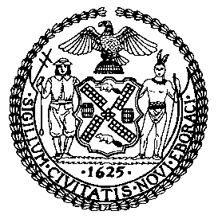

OFFICE OF THE GENERAL COUNSEL
Kathleen Ahn, General Counsel

COMMITTEE REPORT OF THE
COMMITTEE ON RULES, PRIVILEGES AND ELECTIONS
Hon. Brad Lander, Chairperson

March 9, 2016

PRECONSIDERED RESOLUTION NO. 1002

SUBJECT: Resolution Approving Changes in Membership to Certain Standing Committees and an Deletion of a Standing Committee.

ANALYSIS: Before the Committee for its consideration are proposed changes in Committee Membership and deletion of a Standing Committee. See the Resolution for each of the specific changes.

