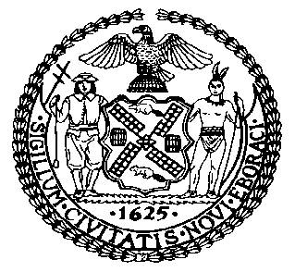 | The Council of the City of New York  Finance Division  Latonia McKinney, Director  Fiscal Impact Statement  Intro. No: 1165  Committee: Housing and Buildings
Title: A Local Law to amend the administrative code of the city of New York, in relation to upgrading lighting systems in certain buildings. | Sponsor(s): Council Members Richards, Constantinides and Chin (in conjunction with the Mayor)
Summary of Legislation: Currently, by January 1, 2025, owners of building 50,000 gross square feet or larger are required to upgrade the lighting systems in their buildings so that they are in compliance with the standards for new systems set forth in the New York City energy conservation code. This bill would expand the upgrade requirements to owners of buildings 25,000 gross square feet or larger. Additionally, building owners would be required to certify and report compliance to the Department of Buildings (“DOB”).

The legislation would exempt buildings where the lighting system is in compliance with the standards outlined in the New York City energy conservation code, residential buildings classified in occupancy groups R-2 or R-3 and places of worship.

Effective Date: This local law would take effect immediately.
Fiscal Year In Which Full Fiscal Impact Anticipated: Fiscal 2018
Fiscal Impact Statement:

 | Effective FY17 | FY Succeeding Effective FY18 | Full Fiscal Impact FY18
Revenues | $0 | $0 | $0
Expenditures | $0 | $0 | $0
Net | $0 | $0 | $0

Impact on Revenues: It is estimated that there would be no impact on revenues resulting from the enactment of this legislation. While DOB may impose a fee for filing and review of compliance reports, these fees are not mandated under this legislation, and thus not assumed in this cost estimate.
Impact on Expenditures: It is anticipated that there would be no impact on expenditures resulting from the enactment of this legislation because existing resources would be used by the DOB to implement the provisions of this local law and building owners would bear any costs of upgrading lighting systems in accordance with the legislation.
Source of Funds To Cover Estimated Costs: Not applicable.

Source of Information: New York City Council Finance Division

Estimate Prepared by: Sarah Gastelum, Senior Legislative Financial Analyst

Estimated Reviewed by: Rebecca Chasan, Counsel
Emre Edev, Assistant Director

Legislative History: Intro. No. 1165 was introduced to the full council on April 20, 2016 and was referred to the Committee on Housing and Buildings. The legislation was considered by the Committee on Housing and Buildings at a hearing held on June 22, 2016 and laid over. The Housing and Buildings Committee will vote on Intro. 1165 on October 13, 2016 and, upon successful vote by the Committee, the legislation will be voted on by the full Council on October 13, 2016.

Date Prepared: October 7, 2016

