THE COUNCIL OF THE CITY OF NEW YORK
RESOLUTION NO. 757

Resolution approving the decision of the City Planning Commission on Application No. N 180230 ZRK, for an amendment of the text of the Zoning Resolution (L.U. No. 320).

By Council Members Salamanca and Moya

WHEREAS, the City Planning Commission filed with the Council on December 28, 2018 its decision dated December 19, 2018 (the "Decision"), pursuant to Section 201 of the New York City Charter, regarding an application submitted by 895 Bedford Avenue Realty, LLC, for an amendment of the text of the Zoning Resolution of the City of New York, modifying Appendix F for the purpose of establishing a Mandatory Inclusionary Housing area on Block 1750, Lots 44, 46, 47, 49, and parts of 1, 24, and 48, which in conjunction with the related action would facilitate the development of a new residential/commercial mixed-use building in the Bedford-Stuyvesant neighborhood of Community District 3, Brooklyn (Application No. N 180230 ZRK), (the "Application");

WHEREAS, the Application is related to application C 180229 ZMK (L.U. No. 319), a zoning map amendment to change an existing M1-2 district to an R7A/C2-4 district;

WHEREAS, the Decision is subject to review and action by the Council pursuant to Section 197-d(b)(1) of the City Charter;

WHEREAS, upon due notice, the Council held a public hearing on the Decision and Application on January 10, 2019;

WHEREAS, the Council has considered the land use implications and other policy issues relating to the Decision and Application; and

WHEREAS, the Council has considered the relevant environmental issues, including the negative declaration issued August 20, 2018 (CEQR No. 18DCP040K), which includes an (E) designation to avoid the potential for significant adverse impacts related to hazardous materials, air quality, and noise (E-491) (the “Negative Declaration”).

RESOLVED:

The Council finds that the action described herein will have no significant impact on the environment as set forth in the Negative Declaration.

Pursuant to Section 200 of the City Charter and on the basis of the Decision and Application, and based on the environmental determination and consideration described in the report, N 180230 ZRK, incorporated by reference herein, and the record before the Council, the Council approves the Decision of the City Planning Commission.

Matter underlined is new, to be added;
Matter struck out is to be deleted;
Matter within # # is defined in Section 12-10;
* * * indicates where unchanged text appears in the Zoning Resolution.

* * *

APPENDIX F
Inclusionary Housing Designated Areas and Mandatory Inclusionary Housing Areas

* * *

BROOKLYN

* * *

Brooklyn Community District 3
* * *
Map 3 - [date of adoption]

[EXISTING MAP]

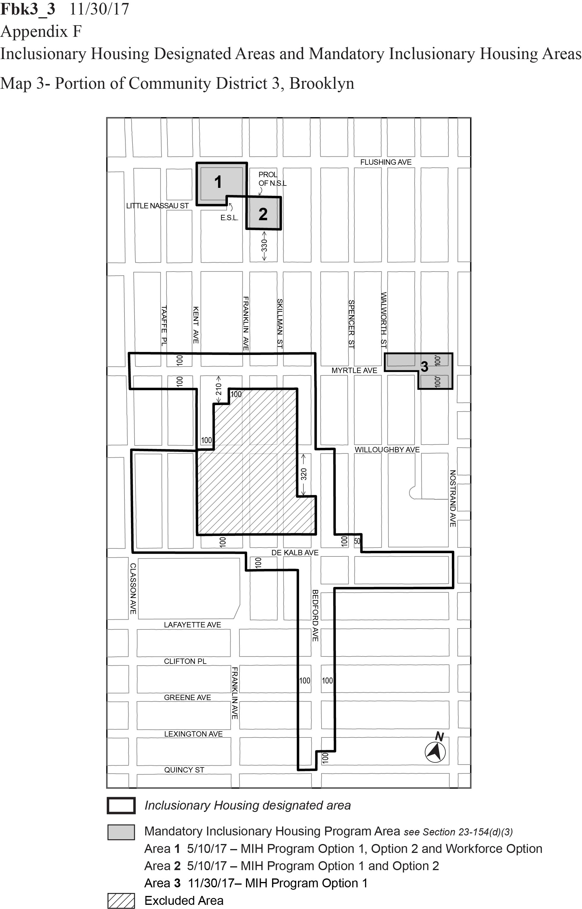
[PROPOSED MAP]
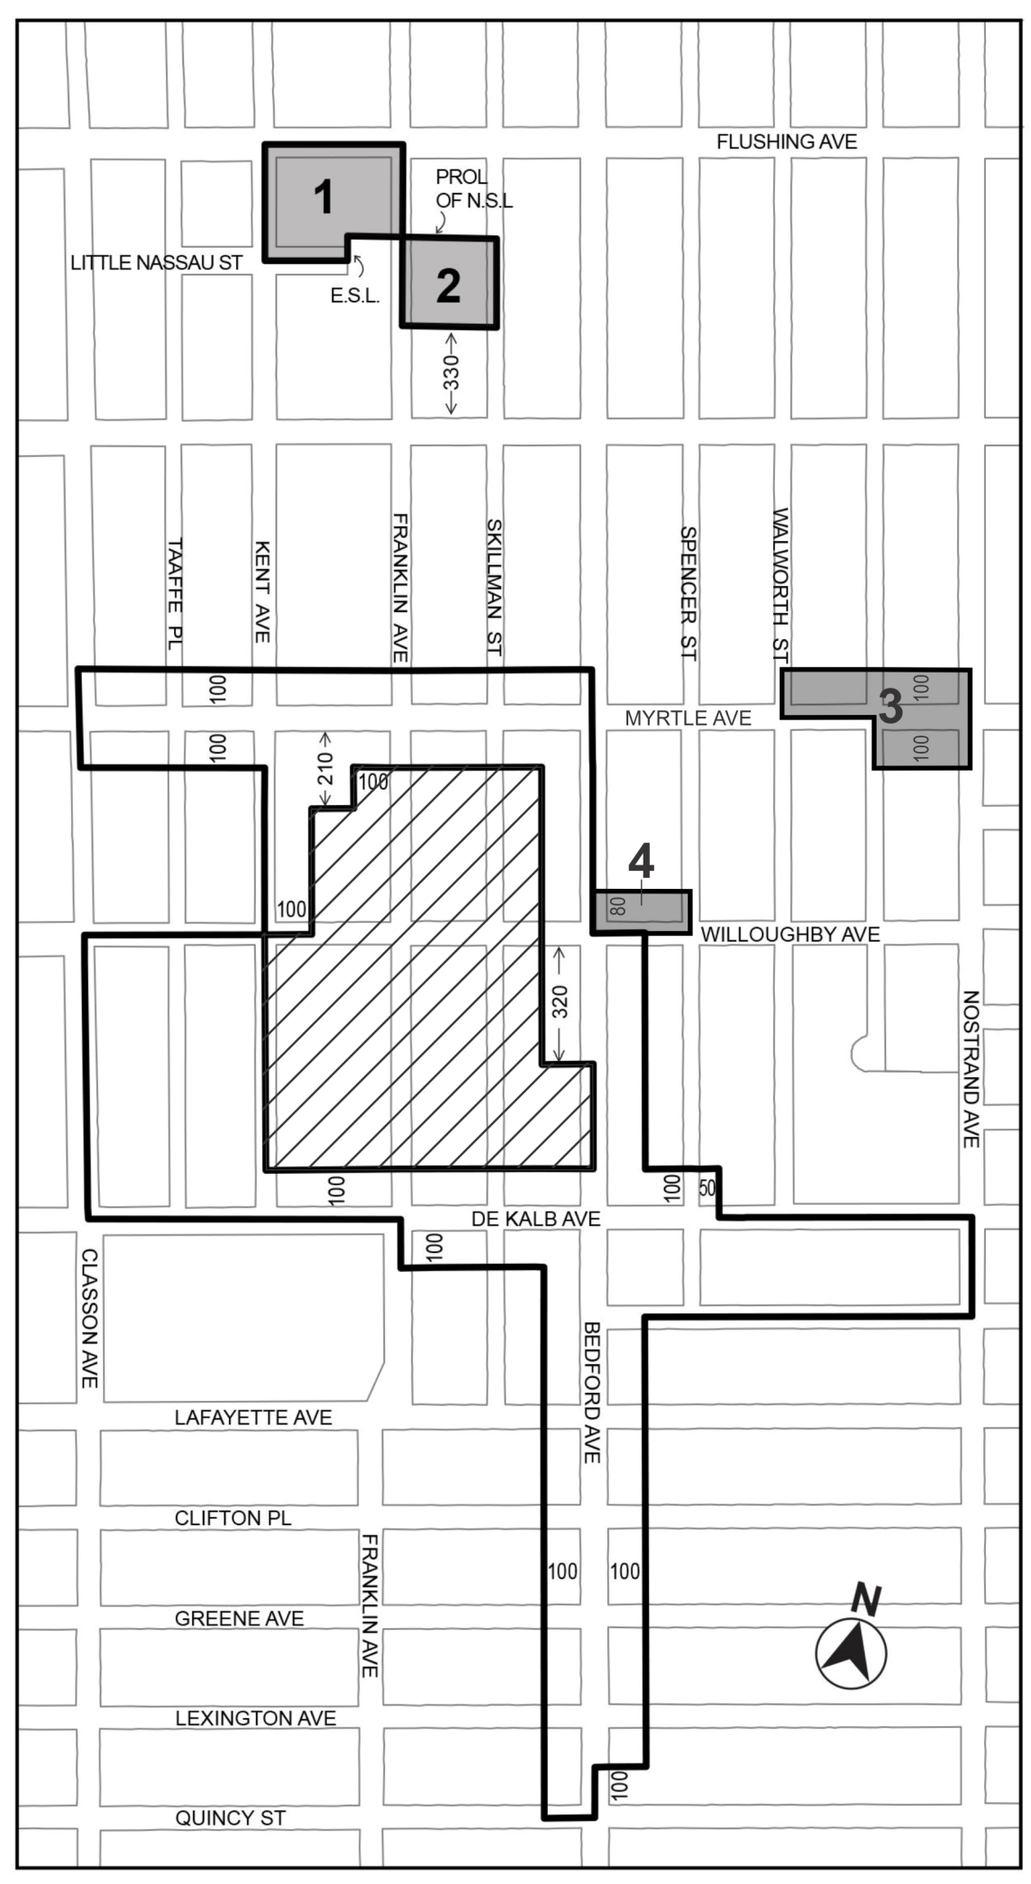
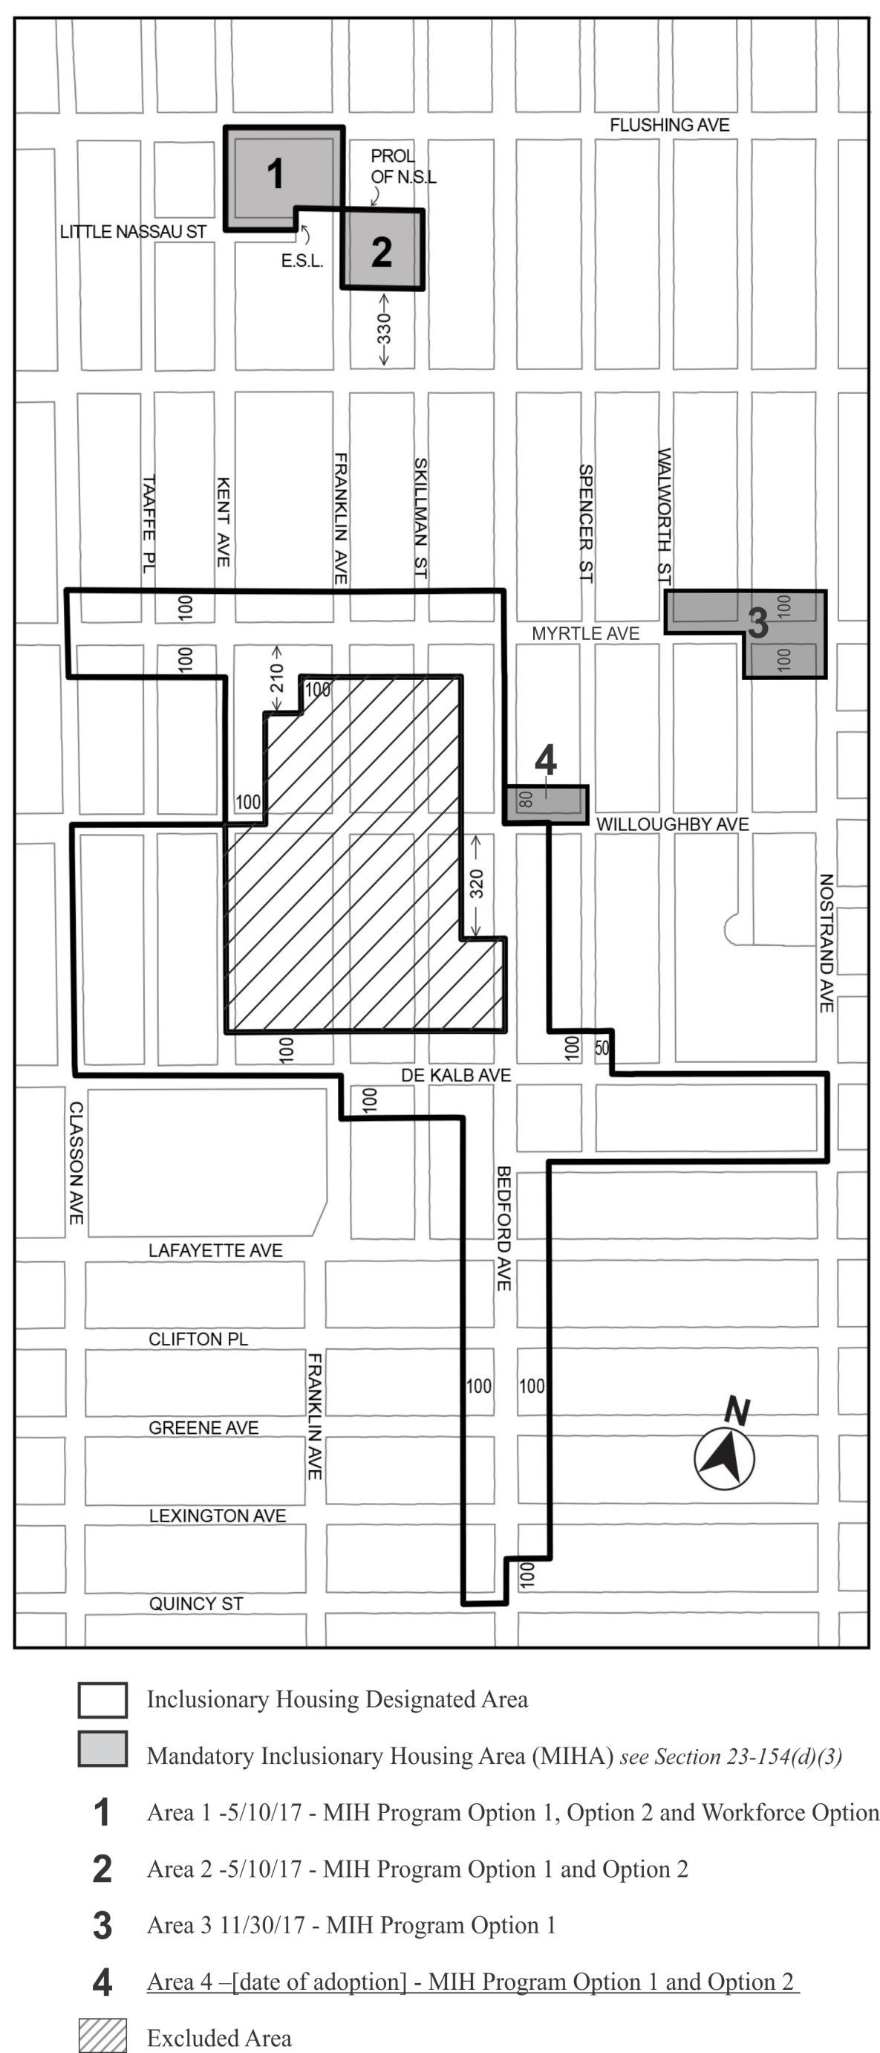

Portion of Community District 3, Brooklyn

* * *

Adopted.

Office of the City Clerk, }
The City of New York, } ss.:

I hereby certify that the foregoing is a true copy of a Resolution passed by The Council of The City of New York on February 13, 2019, on file in this office.

....…….........................................
City Clerk, Clerk of The Council

