THE COUNCIL OF THE CITY OF NEW YORK
RESOLUTION NO. 995

Resolution approving with modifications the decision of the City Planning Commission on Application No. N 180293 ZRK, for an amendment of the text of the Zoning Resolution (Preconsidered L.U. No. 437).

By Council Members Salamanca and Moya

WHEREAS, Merrick Capital Corp., filed an application pursuant to Section 201 of the New York City Charter, for an amendment of the text of the Zoning Resolution of the City of New York, modifying Appendix F for the purpose of establishing a Mandatory Inclusionary Housing area utilizing Option 2, which in conjunction with the related action would facilitate the construction of a new six-story, approximately 36,000-square-foot, mixed-use building with 30 residential units and ground floor commercial space at 2 Howard Avenue (Block 1481, Lot 35) in the Bedford-Stuyvesant neighborhood of Brooklyn Community District 3, (Application No. N 180293ZRK), (the "Application");

WHEREAS, the City Planning Commission filed with the Council on May 10, 2019, its decision dated April 24, 2019 (the "Decision"), on the application

WHEREAS, the Application is related to application C 180292 ZMK (Pre. L.U. No. 436), a zoning map amendment to change an R6B/C2-4 zoning district to a C4-4L district;

WHEREAS, the Decision is subject to review and action by the Council pursuant to Section 197-d of the City Charter;
WHEREAS, upon due notice, the Council held a public hearing on the Decision and Application on May 14, 2019;

WHEREAS, the Council has considered the land use implications and other policy issues relating to the Decision and Application; and

WHEREAS, the Council has considered the relevant environmental issues, including the negative declaration issued December 3rd, 2018 (CEQR No. 18DCP130K), which includes an (E) designations to avoid the potential for significant adverse impacts related to hazardous materials, air quality, and noise (E-513) (the “Negative Declaration”).

RESOLVED:

The Council finds that the action described herein will have no significant impact on the environment as set forth in the (E) Designation (E-513) and Negative Declaration.

Pursuant to Sections 197-d and 200 of the City Charter and on the basis of the Decision and Application, and based on the environmental determination and consideration described in the report, N 180293 ZRK, incorporated by reference herein, and the record before the Council, the Council approves the Decision of the City Planning Commission with the following modifications:

Matter underlined is new, to be added;
Matter struck out is to be deleted;
Matter within # # is defined in Section 12-10;
Matter double struck out is old, deleted by the City Council;
Matter double-underlined is new, added by the City Council
* * * indicates where unchanged text appears in the Zoning Resolution.

* * *

APPENDIX F
Inclusionary Housing Designated Areas and Mandatory Inclusionary Housing Areas

* * *

BROOKLYN

* * *

Brooklyn Community District 3

* * *

Map 6 - [date of adoption]

[PROPOSED MAP]

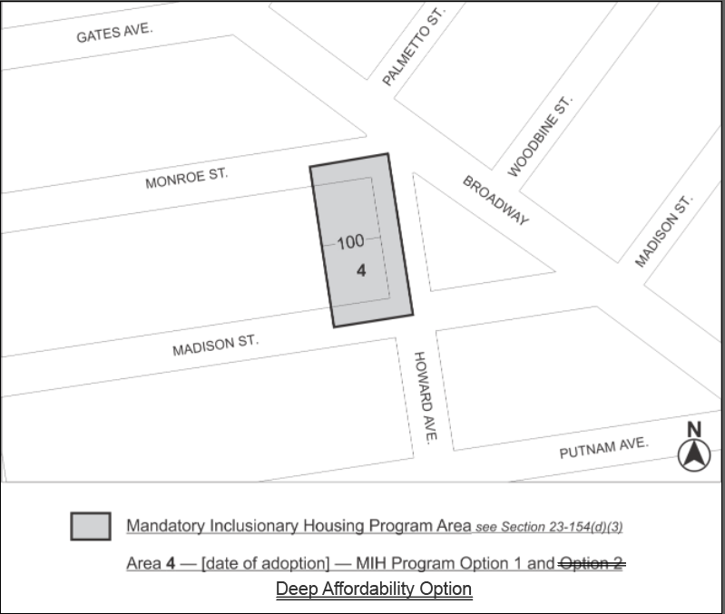

Portion of Community District 3, Brooklyn

* * *

Adopted.

Office of the City Clerk, }
The City of New York, } ss.:

I hereby certify that the foregoing is a true copy of a Resolution passed by The Council of The City of New York on June 26, 2019, on file in this office.

.....……......................................... City Clerk, Clerk of The Council

