THE COUNCIL OF THE CITY OF NEW YORK
RESOLUTION NO. 633

Resolution approving the decision of the City Planning Commission on Application No. N 220284 ZRX, for an amendment of the text of the Zoning Resolution (L.U. No. 185).

By Council Members Salamanca and Riley

WHEREAS, Boston Road Associates, filed an application pursuant to Section 201 of the New York City Charter, for an amendment of the Zoning Resolution of the City of New York, modifying Appendix F for the purpose of establishing a Mandatory Inclusionary Housing Area, which in conjunction with the related action would facilitate the development of a new 10-story mixed-use building with approximately 333 affordable residential units, as well as commercial and community facility uses, at 2560 Boston Road in the Allerton section of Bronx, Community District 11 (ULURP No. N 220284 ZRX) (the “Application”);

WHEREAS, the City Planning Commission filed with the Council on March 31, 2023, its decision dated March 27, 2023 (the “Decision”), on the Application;

WHEREAS, the Application is related to application C 220283 ZMX (L.U. No. 184), a zoning map amendment to change R6 and C8-1 zoning districts to an R7-2/C2-4 zoning district;

WHEREAS, the Decision is subject to review and action by the Council pursuant to Section 197-d of the City Charter;

WHEREAS, upon due notice, the Council held a public hearing on the Decision and Application on April 19, 2023;

WHEREAS, the Council has considered the land use implications and other policy issues relating to the Decision and Application; and

WHEREAS, the Council has considered the relevant environmental issues, including the Conditional Negative Declaration issued October 21, 2022 (CEQR No. 22DCP184X), which includes an (E) designation to avoid the potential for significant adverse impacts related to hazardous materials, air quality, and noise impacts (E-694) and the requirement to enter into a Restrictive Declaration to ensure implementation of measures relating to transportation and construction noise and (the “Negative Declaration”).

RESOLVED:

The Council finds that the action described herein will have no significant impact on the environment as set forth in the Conditional Negative Declaration.

Pursuant to Sections 197-d and 200 of the City Charter and on the basis of the Decision and Application, and based on the environmental determination and consideration described in the report, N 220284 ZRX, incorporated by reference herein, and the record before the Council, the Council approves the Decision of the City Planning Commission.

Matter underlined is new, to be added;
Matter struck out is to be deleted;
Matter within # # is defined in Section 12-10;
* * * indicates where unchanged text appears in the Zoning Resolution

* * *

APPENDIX F
Inclusionary Housing Designated Areas and Mandatory Inclusionary Housing Areas

* * *

THE BRONX

* * *

The Bronx Community District 11

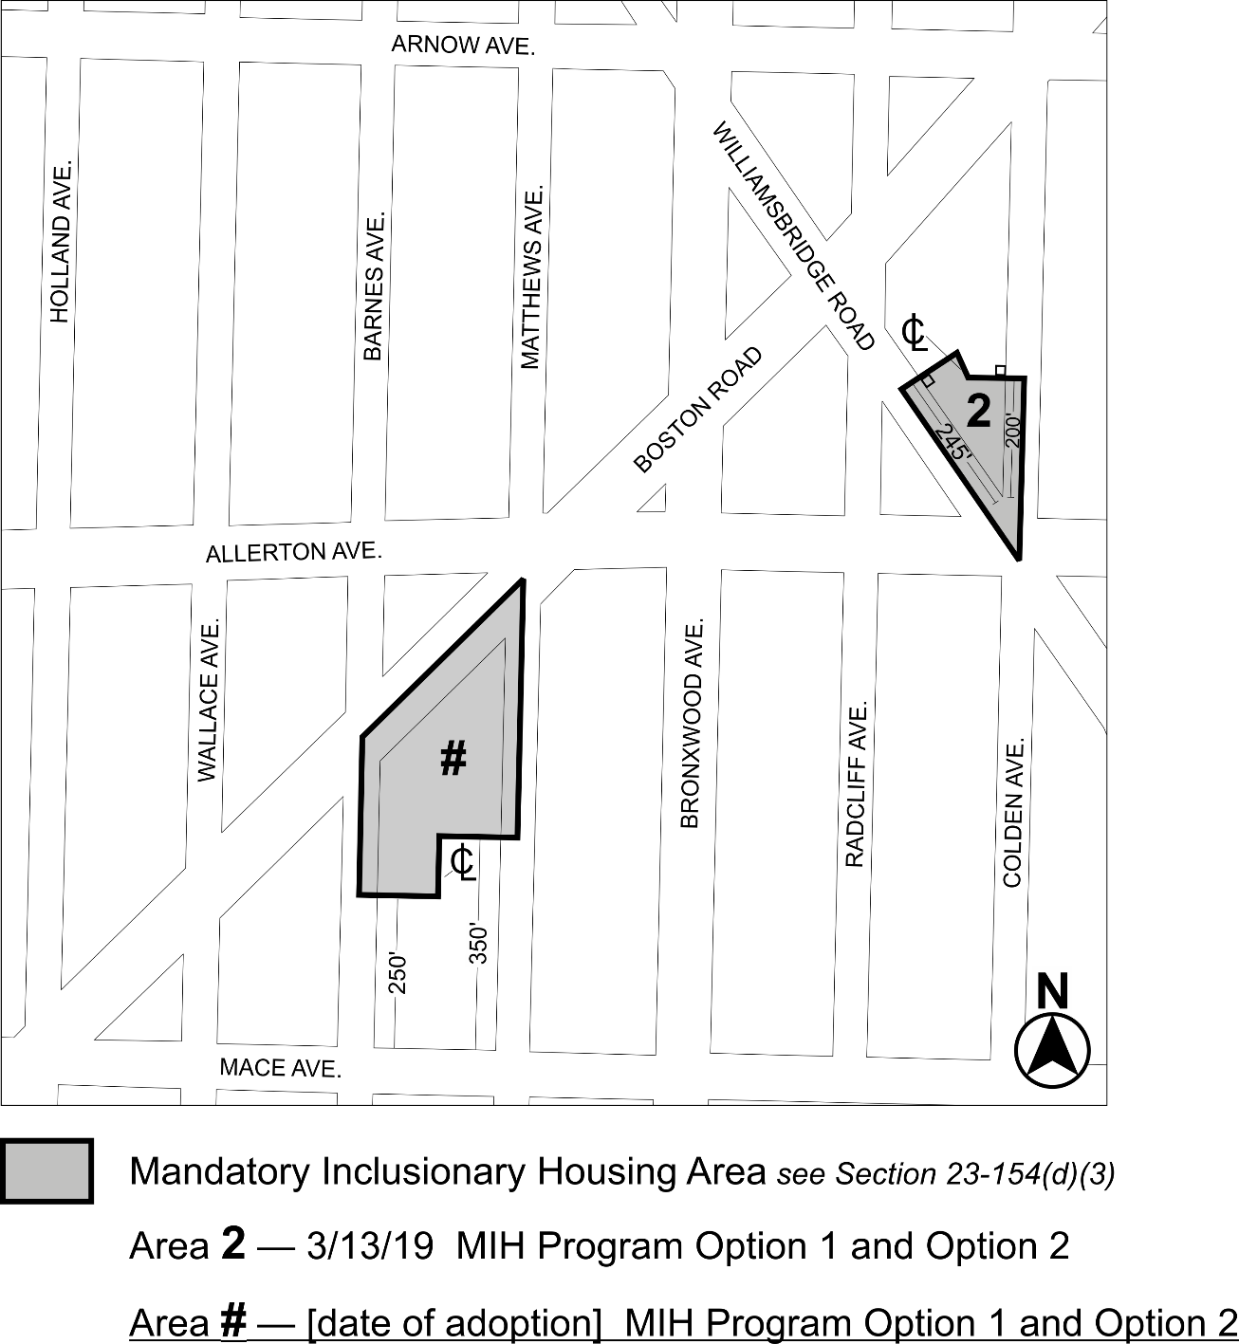

Portion of Community District 11, The Bronx

* * *

Adopted.

Office of the City Clerk, }
The City of New York, } ss.:

I hereby certify that the foregoing is a true copy of a Resolution passed by The Council of The City of New York on _______, 2023, on file in this office.

.....................................................
City Clerk, Clerk of The Council

