THE COUNCIL OF THE CITY OF NEW YORK
RESOLUTION NO. 803

Resolution approving the decision of the City Planning Commission on Application No. N 230292 ZRX, for an amendment of the text of the Zoning Resolution (L.U. No. 265).

By Council Members Salamanca and Riley

WHEREAS, Simone Companies, filed an application for the grant of an authorization, pursuant to Section 201 of the New York City Charter, for an amendment of the text of the Zoning Resolution of the City of New York, modifying Appendix F for the purpose of establishing a Mandatory Inclusionary Housing Area, which in conjunction with the related action would facilitate the development of three new buildings including approximately 970 dwelling units and 100 parking spaces in the cellar, at 1460 –1480 Sheridan Boulevard in the Crotona Park East neighborhood of the Bronx, Community District 9 (ULURP No. N 230292 ZRX), (the “Application”);
WHEREAS, the City Planning Commission filed with the Council on August 25, 2023, its decision dated August 23, 2023 (the "Decision") on the Application;
WHEREAS, the Application is related to application C 230291 ZMX (L.U. No. 264), a zoning map amendment to change an existing M1-1 zoning district to an R7-3/C2-4 zoning district;
WHEREAS, the Decision is subject to review and action by the Council pursuant to Section 197-d of the City Charter;
WHEREAS, upon due notice, the Council held a public hearing on the Decision and Application on September 6, 2023;
WHEREAS, the Council has considered the land use implications and other policy issues relating to the Decision and Application; and
WHEREAS, the Council has considered the relevant environmental issues, including the Positive Declaration issued May 13th, 2022 (CEQR No. 22DCP178X) and a Final Environmental Impact Statement (FEIS) for which a Notice of Completion was issued on August 11, 2023, in which significant adverse impacts related to hazardous materials, air quality, and noise would be avoided through the placement of (E) designations (E-714) on the project sites as specified in FEIS Chapters 10, 13, and 15. To ensure the implementation of the PCREs the applicant will submit the signed Restrictive Declaration at the time of the approval of land use-related actions and prior to issuance of any permits. The proposed project as analyzed in the FEIS identified significant adverse impacts with respect to transportation (vehicular traffic, pedestrian) and construction (vehicular traffic); the identified significant adverse impacts and proposed mitigation measures under the proposed actions are summarized in Chapter 19, “Mitigation” of the FEIS; and to ensure the implementation of the mitigation measures identified in the FEIS, the mitigation measures are included in the Restrictive Declaration.
RESOLVED:
Having considered the FEIS with respect to the Decision and Application, the Council finds that:
- The FEIS meets the requirements of 6 N.Y.C.R.R. Part 617;
- The environmental impacts disclosed in the FEIS were evaluated in relation to the social, economic, and other considerations associated with the action[s] that are set forth in this report; and
- Consistent with social, economic, and other essential considerations, from among the reasonable alternatives provided in the application, the action is one which minimizes or avoids adverse environmental impacts to the maximum extent practicable; and
- The adverse environmental impacts disclosed in the FEIS will be minimized or avoided to the maximum extent practicable by incorporating as conditions to the approval, pursuant to the restrictive declaration dated August 23, 2023, those project components related to the environment and mitigation measures that were identified as practicable.
The Decision, together with the FEIS constitute the written statement of facts, and of social, economic and other factors and standards that form the basis of this determination, pursuant to 6 N.Y.C.R.R. §617.11(d).
Pursuant to Sections 197-d and 200 of the City Charter and on the basis of the Decision and Application, and based on the environmental determination and consideration described in the report, N 230292 ZRX, incorporated by reference herein, and the record before the Council, the Council approves the Decision of the City Planning Commission.
Matter underlined is new, to be added;
Matter struck out is to be deleted;
Matter within # # is defined in Section 12-10;
* * * indicates where unchanged text appears in the Zoning Resolution
* * *
APPENDIX F
Inclusionary Housing Designated Areas and Mandatory Inclusionary Housing Areas
* * *
THE BRONX
* * *
The Bronx Community District 9
* * *
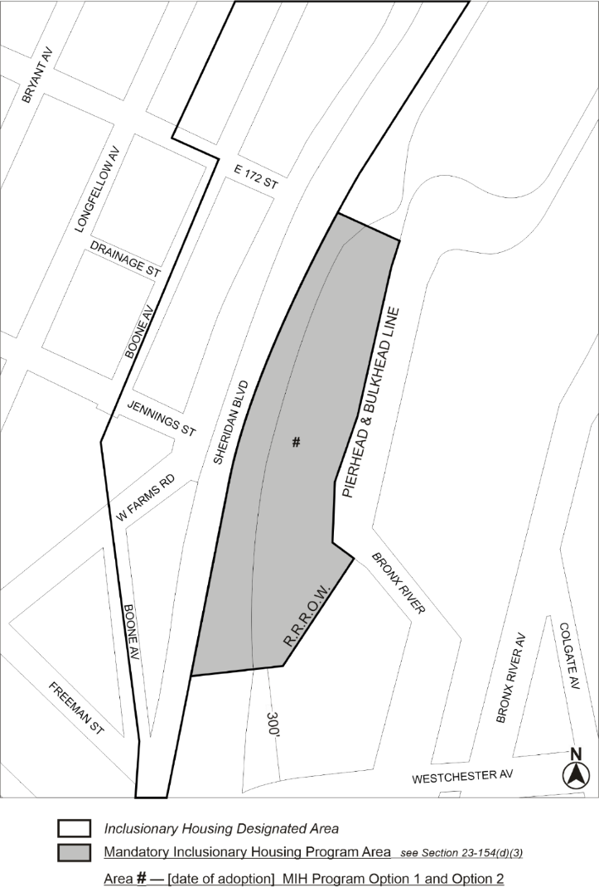

Portion of Community District 9, The Bronx
* * *
Adopted.
Office of the City Clerk,}
The City of New York,} ss.:
I hereby certify that the foregoing is a true copy of a Resolution passed by The Council of The City of New York on _________, 2023, on file in this office.

.....................................................
City Clerk, Clerk of The Council

