THE COUNCIL OF THE CITY OF NEW YORK
RESOLUTION NO. 50

Resolution approving with modifications the decision of the City Planning Commission on Application No. N 200328 ZRK, for an amendment of the text of the Zoning Resolution (Preconsidered L.U. No. 9).

By Council Members Salamanca and Riley

WHEREAS, Mikerose Realty, Inc., filed an application pursuant to Section 201 of the New York City Charter, for an amendment of the text of the Zoning Resolution of the City of New York, modifying APPENDIX F for the purpose of establishing a Mandatory Inclusionary Housing Area, which in conjunction with the related action would facilitate the development of a new nine-story, approximately 43,000-square-foot mixed-use development that would contain approximately 3,800 square feet of commercial use and approximately 3,600 square feet of community facility use, as well as 55 residential units, approximately 14 of which would be designated as permanently affordable pursuant to the Mandatory Inclusionary Housing (MIH) program, at 2892 Nostrand Avenue in the Madison neighborhood of Community District 15, Brooklyn (Application No. N 200328 ZRK) (the “Application”);

WHEREAS, the City Planning Commission filed with the Council on January 21, 2022, its decision dated January 5, 2022 (the “Decision”), on the Application;

WHEREAS, the Application is related to application C 200329 ZMK (Pre. L.U. No. 8), a zoning map amendment to change an R3-2 zoning district to R6B/C2-4, R7A, and R7A/C2-4 zoning districts;

WHEREAS, the Decision is subject to review and action by the Council pursuant to Section 197-d of the City Charter;

WHEREAS, upon due notice, the Council held a public hearing on the Decision and Application on January 27, 2022;

WHEREAS, the Council has considered the land use implications and other policy issues relating to the Decision and Application; and

WHEREAS, the Council has considered the relevant environmental issues, including the Negative Declaration issued August 16th, 2021 (CEQR No. 20DCP148K), which includes an (E) designation to avoid the potential for significant adverse impacts related to hazardous materials, air quality, and noise (E-579) (the “Negative Declaration”).

RESOLVED:

The Council finds that the action described herein will have no significant impact on the environment as set forth in the (E) Designation (E-579) and Negative Declaration.

Pursuant to Sections 197-d and 200 of the City Charter and on the basis of the Decision and Application, and based on the environmental determination and consideration described in the report, N 200328 ZRK, incorporated by reference herein, and the record before the Council, the Council approves the Decision of the City Planning Commission, with the following modifications:

Matter underlined is new, to be added;
Matter struck out is to be deleted;
Matter within # # is defined in Section 12-10;
* * * indicates where unchanged text appears in the Zoning Resolution.
Matter double struck out is old, deleted by the City Council;
Matter double-underlined is new, added by the City Council

APPENDIX F
Inclusionary Housing Designated Areas and Mandatory Inclusionary Housing Areas

* * *
BROOKLYN

* * *

Brooklyn Community District 15

Map 2 - August 16, 2021

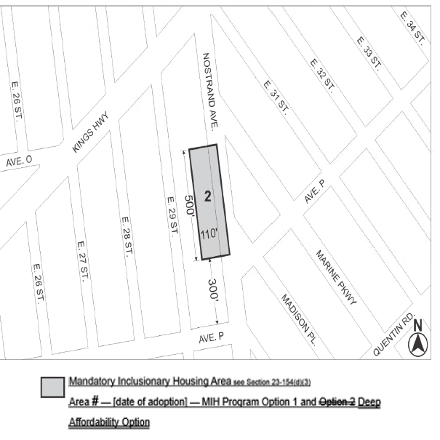

Portion of Community District 15, Brooklyn

* * *

Adopted.

Office of the City Clerk, }
The City of New York, } ss.:

I hereby certify that the foregoing is a true copy of a Resolution passed by The Council of The City of New York on ____________, 2022, on file in this office.

.....................................................
City Clerk, Clerk of The Council

