THE COUNCIL OF THE CITY OF NEW YORK
RESOLUTION NO. 843

Resolution approving with modifications the decision of the City Planning Commission on Application No. N 220454 ZRK, for an amendment of the text of the Zoning Resolution (L.U. No. 276).

By Council Members Salamanca and Riley

WHEREAS, Ranco Capital, LLC, filed an application pursuant to Section 201 of the New York City Charter, for an amendment of the text of the Zoning Resolution of the City of New York, modifying APPENDIX F for the purpose of establishing a Mandatory Inclusionary Housing area, which in conjunction with the related action would facilitate the construction of a new eight-story residential building containing 54 dwelling units, eighteen of which would be permanently income restricted, at 703 Myrtle Avenue in the Bedford-Stuyvesant neighborhood of Brooklyn, Community District 3 (ULURP No. N 220454 ZRK), (the “Application”);

WHEREAS, the City Planning Commission filed with the Council on September 15, 2023, its decision dated September 11, 2023 (the "Decision") on the Application;

WHEREAS, the Application is related to application C 220453 ZMK (L.U. No. 275), a zoning map amendment to change an M1-1 zoning district to an R7D/C2-4 zoning district;

WHEREAS, the Decision is subject to review and action by the Council pursuant to Section 197-d of the City Charter;

WHEREAS, upon due notice, the Council held a public hearing on the Decision and Application on September 19, 2023;

WHEREAS, the Council has considered the land use implications and other policy issues relating to the Decision and Application; and

WHEREAS, the Council has considered the relevant environmental issues, including the Negative Declaration issued April 21st, 2023 (CEQR No. 21DCP203K), which includes an (E) designation to avoid the potential for significant adverse impacts related to hazardous materials, air quality and noise impacts (E-695) (the “Negative Declaration”).

RESOLVED:

The Council finds that the action described herein will have no significant impact on the environment as set forth in the (E) Designation (E-695) and Negative Declaration.

Pursuant to Sections 197-d and 201 of the City Charter and on the basis of the Decision and Application, and based on the environmental determination and consideration described in the report, N 220454 ZRK, incorporated by reference herein, and the record before the Council, the Council approves the Decision of the City Planning Commission, with the following modifications.

Matter underlined is new, to be added;
Matter struck out is to be deleted;
Matter within # # is defined in Section 12-10;
* * * indicates where unchanged text appears in the Zoning Resolution.
Matter double struck out is old, deleted by the City Council;
Matter double-underlined is new, added by the City Council

* * *

APPENDIX F
Inclusionary Housing Designated Areas and Mandatory Inclusionary Housing Areas

* * *

BROOKLYN

* * *

Brooklyn Community District 3

* * *

[EXISTING]

Map 3 – (11/10/21)

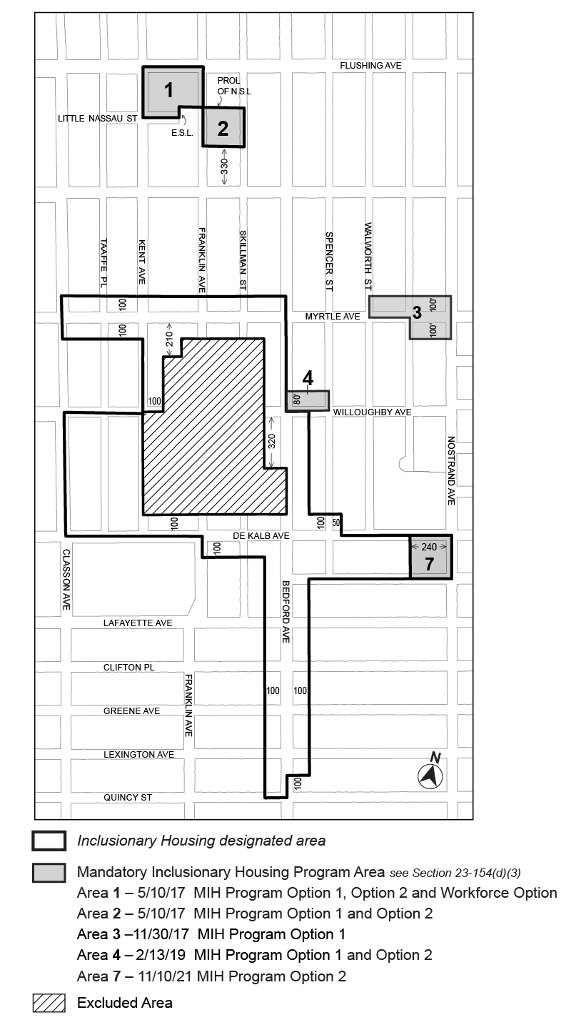
[PROPOSED]
Map 3 – (Date of adoption)
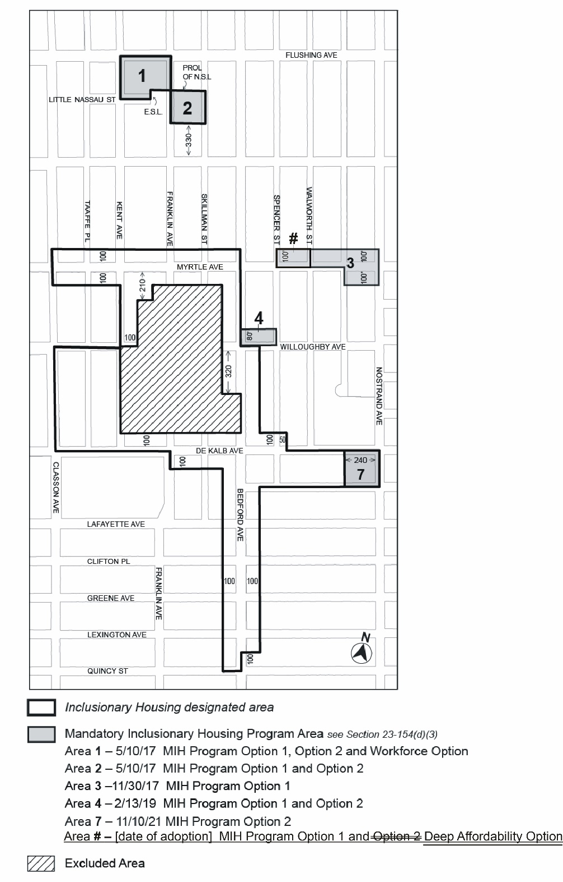
* * *

Adopted.

Office of the City Clerk,}
The City of New York,} ss.:

I hereby certify that the foregoing is a true copy of a Resolution passed by The Council of The City of New York on _________, 2023, on file in this office.

.....................................................
City Clerk, Clerk of The Council

